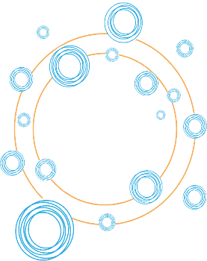

Culture Connects CARES
Artist Mini-Grants for Hope and COVID Safe Practices

Hard copy APPLICATION
DUE: US Post Mark by 5pm October 16, 2020
Mail to: Arts and Culture Department/City of Santa Fe
PO Box 909
Santa Fe, NM 87504-0909

Please fill out the following completely and legibly:

Name
Address
Email
Phone

YES | NO | Please answer the following
 |  | Do you identify as Black, Indigenous, Person of Color or person with disability and/or traditionally disenfranchised community.
 |  | Are you at least 18 years of age?
 |  | Are you able to receive/cash a check?

By submitting your application, you agree to:
1. Allow the City of Santa Fe to use the artworks created for non-commercial purposes to promote COVID Safe Practices and to be featured on the City’s online platforms, print materials and other forms of communication
2. Be featured on the City of Santa Fe’s Arts and Culture Department online platforms

Please answer the following questions – BRIEFLY, no more than 500 words

Project Description - 10 points
Describe the project you propose as it relates to hope during COVID and CSP messaging? Please include Who, What, When, Where, Why descriptions to explain your vision briefly and clearly. If you have a sketch, drawing, video, etc. please include but NOT required.

Intentions for Public Impact - 10 points
What is the expected public impact? How will you ensure that you reach and/or achieve it? Who is your desired audience?

Project Evaluation 5 points
What does “success” look like? What do you hope to achieve?

