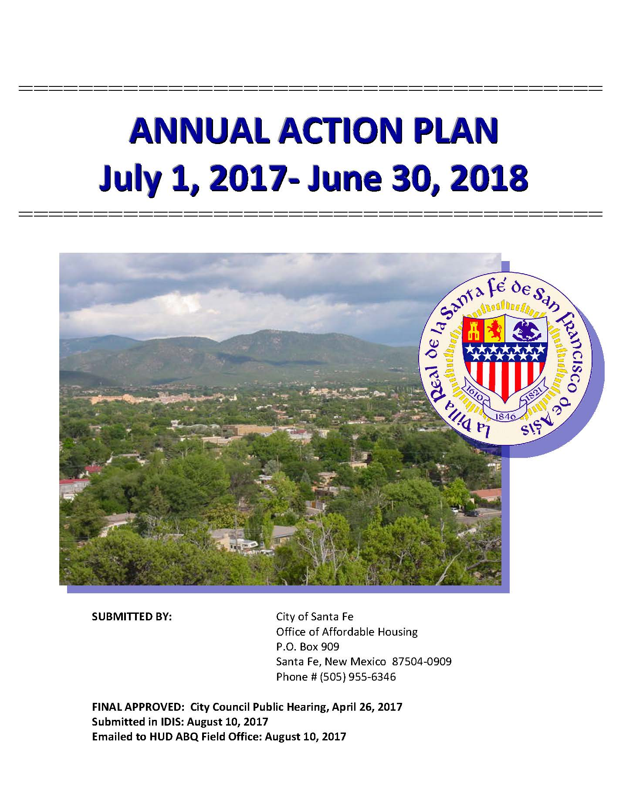

Executive Summary

AP-05 Executive Summary - 24 CFR 91.200(c), 91.220(b)
1. Introduction
The purpose of the Action Plan is to stipulate how funds will be allocated to housing and community development activities in Santa Fe based on the needs, priorities, goals and strategies identified in the 2013-2017 Consolidated Plan.
2. Summarize the objectives and outcomes identified in the Plan
This could be a restatement of items or a table listed elsewhere in the plan or a reference to another location. It may also contain any essential items from the housing and homeless needs assessment, the housing market analysis or the strategic plan.
The City of Santa Fe’s focus over the next year is to improve and sustain affordable housing, rental, homeownership, and economic opportunities for low- to moderate-income households in Santa Fe, as well as addressing the needs of those experiencing homelessness or at risk of becoming homeless. The City will accomplish this by administering program funds to service providers, supporting collaboration and strategically applying resources to community needs.
This Plan identifies the following goals as they relate to HUD-mandated objectives and outcomes for its upcoming housing and community development activities:
GOAL: Reduced rate of cost burden and corresponding drop in poverty rate for homeless households and those at risk of becoming homeless.
- Objective: Creating Suitable Living Environments
- Outcome: Availability/Accessibility
GOAL: Expanded inventory of rental units and vouchers to meet increased needs of renters with very low incomes.
- Objective: Providing Decent Housing
- Outcome: Availability/Accessibility
GOAL: Increased homeownership opportunities and support for long-term affordability and accessibility for current homeowners.
- Objective: Providing Decent Housing
- Outcome: Availability/Accessibility
To best understand the need and to work toward meeting these housing goals, the City utilizes the Santa Fe Affordable Housing Plan, finalized in December 2016, a five-year plan required by the New Mexico Mortgage Finance Authority, which assesses housing need in Santa Fe and provides recommendations for addressing the needs. The housing needs analysis portion examines housing needs across all income levels to identify mismatches in supply and demand for all households in Santa Fe. One of the essential items this document provides to the City is a gaps analysis, which compares the demand for and supply of housing by income level. Instead of estimating the type of housing each household in the city would prefer, income is used as a proxy, as it is the most important factor in accessing housing.
The gaps analysis shows the following:
- The greatest need in Santa Fe’s market is for rental units priced between $375 and $500 per month, serving renters earning between $15,000 and $20,000 per year. In this income range, there is a current shortage of 800 rental units, up from 715 in 2011.
- The rental gap for households earning $20,000 to $25,000 also increased between 2011 and 2014—from 169 to 444. However, the cumulative rental gap, for all households earning less than $25,000 declined from 3,074 in 2011 to 2,435 in 2014.
- The gaps model estimates that as many as 2,435 renters earning $25,000 and less cannot find affordable units and, as such, are cost burdened. Most of these renters earn less than $20,000.
- The median home value declined by 8.5 percent between 2011 and 2014, increasing ownership affordability for some city residents. In 2014 nearly one-quarter of renters could afford the median value home, up from 14 percent in 2011. This increase in homeownership affordability is also a result of renters’ incomes increasing since 2011.
- Over 400 homes are in substandard condition (incomplete kitchen/plumbing facilities) and are in probable need of rehabilitation.*
*City of Santa Fe Office of Affordable Housing, BBC Research & Consulting: City of Santa Fe Affordable Housing Plan (December 2016), pg.III, accessed at www.santafenm.gov/office_of_affordable_housing_policy_reserarch) .
3. Evaluation of past performance
This is an evaluation of past performance that helped lead the grantee to choose its goals or projects.
The following bullets outline progress in meeting goals identified in the 2013-2017 Consolidated Plan, almost all of which were met, or exceeded. These achievements are a testament to the strong partnerships the City supports with its nonprofit partners and subrecipient contractors.
- The City's goal for rental housing as stated in the 2016-2017 Action plan was to serve renters earning less than 60 percent of Santa Fe's Area Median Income (AMI). Approximately 20 very low income renters with disabilities, many of whom are transitioning out of homelessness, were served through two Shelter Plus Care grants administered by the City. For the 2017-2018 program year, the City allocated $400,000 of Affordable Housing Trust Fund (AHTF) to rental facility improvements as well as down payment assistance. The City hopes that surplus funds during the program year will allow the implementation of a new rental assistance program for very low-income renters as was done in prior years.
- The City's goal for home ownership housing as outlined in the current 2016-2017 Action Plan is to provide comprehensive assistance to low-to-moderate-income homebuyers in the form of down payment assistance. The goal states that this funding type will serve approximately 12 households for year with CDBG funding alone. As of March 2017, 20 households were served with down payment assistance administered between two sub-recipients receiving CDBG and one AHTF contract that was extended to 12-31-2016. This program exceeded the goal of serving 12 homebuyers.
- The City's goal for emergency shelters and permanent supported rental housing as outlined in the 2016-2017 Action Plan is to provide 33 permanent beds and/or longer-term units per year. As of June 30, 2017, approximately 30 shelter beds were provided for 40 families of mainly Female-Headed Households via Casa Familia. In the upcoming 2017-2018 program year, CDBG funds are proposed for services including referrals and support the Interfaith Women's Summer Safe Haven for a minimum of 300 women. Youth Shelters and Family Services will continue the Street Outreach Program to target a minimum of 625 youth and will track those served via outreach who utilize the Drop in Center as well as their Transitional Living Program.
- The City's goal for home improvement as outlined in the 2016-2017 Action Plan was to support energy efficiency upgrades, required accessibility renovations and emergency repairs for 13 households between two service providers. As of March 2017, nine (9) loans were made and three (3) loans are pending approval, all supporting low and moderate-income homeowners, many of whom are elderly. Thus far, loan recipients have been able to significantly reduce their long-term energy costs, while others received assistance to bring their homes into compliance with basic housing quality standards.
4. Summary of Citizen Participation Process and consultation process
Summary from citizen participation section of plan.
Requests for Proposals (RFP's) for CDBG and the AHTF were advertised in the Santa Fe New Mexican and the Albuquerque Journal on January 3, 2017. Two technical trainings for RFP proponents were held on January 17. Applicant presentations took place at the Community Development Commission Public Meeting on February 15. Funding recommendations were made and the 2017-2018 Draft Action Plan was completed; however, the City had not yet received notice of its funding allocation from HUD so an estimated amount of $500,000 was used. In addition to the City’s public participation process as described in the following, an updated draft using the City’s actual entitlement amount of $530,468 was noticed for a 14-day public comment period.
As per the initial public review process, copies of the updated Plan were placed at the following for public review: Main and Southside Santa Fe Public Library branches, the City's Market Street Office and Santa Fe City Hall from July 24, 2017 - August 7, 2017. (The initial public review comment period with the estimated amount of $500,000 began March 10, 2017 and ended April 11, 2017). The draft plan and activities selected for funding were discussed at the March 16 City News Hour on KSFR 101.5FM. Lastly, a Press Release on the plan was issued by the City’s Public Information Office on March 20 and is in the Addenda to this plan. For the updated draft, display advertisements in Spanish and English were placed in the Santa Fe New Mexican on Monday, July 24, 2017 announcing the public review and comment period and contact information for submitting comments. Notice is provided that Spanish translation is available upon request. Paper copies are also made available for review. No comments were received. NOTE: HUD does not require additional public meetings/hearings for the current draft plan with the amended funding amount as the projects funded and initially reported will remain the same.
For the initial draft, three public meetings and one public hearing were held for notification of the Plan and/or review:
- The Community Development Commission Public Meeting for Funding Recommendations (February 15, 2017)
- Request to Publish the 30-day Notice of Public Hearing (March 8, 2017)
- The City of Santa Fe's Finance Committee Public Meeting (April 3, 2017)
- The City of Santa Fe's Community Development Commission Public Meeting (April 19, 2017)
- The Santa Fe City Council Public Hearing (April 26, 2017)
These meetings are open to the public and agendas are available on the City's website. The public meetings and public hearing are conveniently timed and located to encourage participation and can all be made accessible to people with disabilities, including sign language interpretation with prior notice to the City Clerk's office. The meetings are also publicized in Spanish and state that a translator may be made available upon request in advance. The public hearing allows members of the public to make comments as part of the Governing Body’s discussion of the item. At the public meetings, there is an opportunity for the public to speak from the floor.
5. Summary of public comments
This could be a brief narrative summary or reference an attached document from the Citizen Participation section of the Con Plan.
Comments from the general public as well as plan participants and stakeholders are noted in this section when received. None were received.
6. Summary of comments or views not accepted and the reasons for not accepting them
Comments that are not accepted will be noted where applicable.
7. Summary
Over the next year, the Office of Affordable Housing will continue to work on strategies that prevent the most vulnerable City residents from falling into cycles of poverty and chronic homelessness, target low income "at risk" neighborhoods with comprehensive programming interventions, and work with the larger community to identify ways that community needs can be more effectively and efficiently identified and met with limited community resources. At present, the Office of Affordable Housing is involved in the Permanent Supportive Housing Toolkit. The toolkit is a series of sessions conducted by affordable housing professionals and attended by stakeholders across the state to talk with supportive housing developers, understand development budgets, and identify gap funders. These trainings are facilitated by the Pathways Home group, a partnership between LeBeau Development, Enterprise Community Partners and the New Mexico Coalition to End Homelessness.
By focusing on these strategies in the 2017-2018 Action Plan, the City of Santa Fe hopes to ensure that all City residents have access to affordable, accessible and high quality housing opportunities.

PR-05 Lead & Responsible Agencies – 91.200(b)
1. Agency/entity responsible for preparing/administering the Consolidated Plan
Describe the agency/entity responsible for preparing the Consolidated Plan and those responsible for administration of each grant program and funding source.
Agency Role | Name | Department/Agency
Lead Agency | SANTA FE

CDBG Administrator | SANTA FE | Office of Affordable Housing/City of Santa Fe
HOPWA Administrator
HOME Administrator
HOPWA-C Administrator
Table 1 – Responsible Agencies
Narrative (optional)
The City of Santa Fe's Office of Affordable Housing which is a division of the City's General Government Department, administers the Community Development Block Grant (CDBG), the Continuum of Care/Shelter Plus Care program, the Affordable Housing Trust Fund (AHTF), and other local funds to support housing and community development activities in Santa Fe.
Consolidated Plan Public Contact Information
Alexandra Ladd
Director, Office of Affordable Housing
City of Santa Fe
P.O. Box 909
Santa Fe, NM 87504-0909
agladd@santafenm.gov
505-955-6346

AP-10 Consultation – 91.100, 91.200(b), 91.215(l)
1. Introduction
Provide a concise summary of the jurisdiction’s activities to enhance coordination between public and assisted housing providers and private and governmental health, mental health and service agencies (91.215(l))
The City's Office of Affordable Housing coordinates closely with other Departments including the Youth and Family Services Division of the Community Services Department that funds emergency housing and community development programs as well as social services. The other division, Children + Youth Commission provides funding and support for local nonprofit organizations and public school programs for kids. Approximately one million dollars is awarded annually in the following five categories: Early Care and Child Development; Healthy Living; Outdoor Education and Environmental Awareness and Supplemental Educational Programs for students in Santa Fe Public Schools. These Divisions within the City coordinate closely with the CDBG Program. The Human Services Committee makes funding recommendations to City Council from the General Fund for local residents to include basic food and shelter, medical, and other safety net services. The Community Services Department posts Request for Proposals on the City’s website in March 2017 and funding recommendations are made to the governing body in May 2017.
Many beneficiaries of this funding also are recipients of public housing services. Some of the City’s CDBG sub-recipients and the Santa Fe Civic Housing Authority coordinate outreach activities and some programming is located at housing authority sites.
Describe coordination with the Continuum of Care and efforts to address the needs of homeless persons (particularly chronically homeless individuals and families, families with children, veterans, and unaccompanied youth) and persons at risk of homelessness.
Santa Fe is not served by a local Continuum of Care but rather is covered by New Mexico’s Balance of State Continuum of Care, as administered by the New Mexico Coalition to End Homelessness. City staff from the Housing and Community Development Department serve on the Board for the Balance of State Continuum of Care, which requires attending monthly meetings by conference call and quarterly meetings of the all the stakeholder agencies. Staff also attends the annual Housing for All Conference, hosted by the NM Coalition to End Homelessness.

Describe consultation with the Continuum(s) of Care that serves the jurisdiction's area in determining how to allocate ESG funds, develop performance standards for and evaluate outcomes of projects and activities assisted by ESG funds, and develop funding, policies and procedures for the operation and administration of HMIS
The City of Santa Fe does not directly participate in any ESG (Emergency Solutions Grants) programming to assist the homeless or those at risk. The Continuum of Care Board has developed standards based on the HUD established outcome measures for housing stability and increasing client income for Continuum of Care Programs. The Board is working with the staff of the New Mexico Coalition to End Homelessness and the New Mexico Mortgage Finance Authority on the standards and evaluation of ESG-funded projects.
2. Describe Agencies, groups, organizations and others who participated in the process and describe the jurisdiction’s consultations with housing, social service agencies and other entities

Table 2 – Agencies, groups, organizations who participated
1 | Agency/Group/Organization | SANTA FE CIVIC HOUSING AUTHORITY
 | Agency/Group/Organization Type | Housing  PHA
 | What section of the Plan was addressed by Consultation? | Public Housing Needs
 | Briefly describe how the Agency/Group/Organization was consulted. What are the anticipated outcomes of the consultation or areas for improved coordination? | The sections of the 2017 Draft AAP are highlighted and the information is emailed for verification or update. Since their organization deals with these issues on a daily basis, accurate and precise data is anticipated. The SFCHA has received a completed copy of the document for review.
2 | Agency/Group/Organization | THE LIFE LINK
 | Agency/Group/Organization Type | Housing  Services - Housing  Services-homeless
 | What section of the Plan was addressed by Consultation? | Homeless Needs - Chronically homeless  Homeless Needs - Families with children  Homelessness Needs - Veterans
 | Briefly describe how the Agency/Group/Organization was consulted. What are the anticipated outcomes of the consultation or areas for improved coordination? | The sections of the 2017 Draft AAP are highlighted and emailed for verification or update. Since these organizations deal with these issues on a daily basis, accurate and precise data is provided to inform this plan.
3 | Agency/Group/Organization | ST ELIZABETH SHELTER
 | Agency/Group/Organization Type | Housing  Services - Housing  Services-Elderly Persons  Services-Persons with HIV/AIDS  Services-homeless  Services - Victims
 | What section of the Plan was addressed by Consultation? | Homeless Needs - Chronically homeless  Homeless Needs - Families with children  Homelessness Needs - Veterans  Homelessness Strategy
 | Briefly describe how the Agency/Group/Organization was consulted. What are the anticipated outcomes of the consultation or areas for improved coordination? | The sections of the 2017 Draft AAP are highlighted and emailed for verification or update. Since these organizations deal with these issues on a daily basis, accurate and precise data is provided to inform this plan.
4 | Agency/Group/Organization | The Housing Trust
 | Agency/Group/Organization Type | Housing  Services - Housing  Service-Fair Housing  Business and Civic Leaders  Community Development Financial Institution
 | What section of the Plan was addressed by Consultation? | HOPWA Strategy
 | Briefly describe how the Agency/Group/Organization was consulted. What are the anticipated outcomes of the consultation or areas for improved coordination? | The sections of the 2017 Draft AAP are highlighted and emailed for verification or update. Since these organizations deal with these issues on a daily basis, accurate and precise data is provided to inform this plan.

Identify any Agency Types not consulted and provide rationale for not consulting
There were none.

Other local/regional/state/federal planning efforts considered when preparing the Plan
Name of Plan | Lead Organization | How do the goals of your Strategic Plan overlap with the goals of each plan?
Continuum of Care | New Mexico Coalition to End Homelessness | Seeks to provide comprehensive support services aligned with housing to keep people housed.
5 Year Strategic Housing Plan | City of Santa Fe | The Housing Plan incorporates a needs assessment that looks at housing affordability as it relates to unit inventory and demand; it is used by the City to shape policy and funding decisions. This document was finalized in January 2017.
PHA 5-Year and Annual Plan | Santa Fe Civic Housing Authority | Many of the goals are incorporated into this plan
Five Year Plan to End Homelessness (2012) | New Mexico Coalition to End Homelessness | The goals of that plan are incorporated into this plan
2012-2017 CIP Plan | City of Santa Fe | Project priorities help shape the funding priorities in this plan.
Assessment of Fair Housing (in Progress, September | City of Santa Fe | Successor to the A/I, this document is a new HUD requirement and the research seeks to clarify existing fair housing obligations, set locally-determined fair housing priorities and goals, connect fair housing planning to subsequent community planning and development via a jurisdictionâ¿¿s Consolidated Plan, Annual Action Plans, and Public Housing Authority (PHA) plans, (as applicable), and, ultimately, set up a framework for taking meaningful actions to affirmatively further fair housing. Much of its framework was incorporated in the AI listed above. Pending approval of the consultant contract, work begins in April 2017 and draft will be available for public review in July 2017.
Table 3 – Other local / regional / federal planning efforts

Narrative (optional)

AP-12 Participation – 91.105, 91.200(c)
1. Summary of citizen participation process/Efforts made to broaden citizen participation
Summarize citizen participation process and how it impacted goal-setting
As specified in the prior section “Summary of Citizen Participation and Consultation Process”, paper copies of the draft 2017-2018 Action Plan are placed at five locations for public review. The initial period was March 10, 2017 through April 11, 2017, complying with HUD’s required 30-day review period. For the actual entitlement award of $530,468, HUD is allowing a 14-day comment period and because the projects funded and initially reported will remain the same, additional public meetings/hearings for the current draft plan are not required.
For the initial draft, advertisements were placed in the Santa Fe New Mexican on Friday, March 10 and Friday, March 17 announcing the public review and comment period. The advertisement for the 30-day notice of public hearing was published in the Santa Fe New Mexican the week of March 14 and was advertised by the City Clerk in English and Spanish. The ads stated where the copies were available for review as well as contact information for submitting comments. NOTE: the amended draft of the Action Plan was advertised following the same procedure with a 14-day comment period running from July 24 through August 7, 2017.
For the initial draft, two public meetings and one public hearing were held seeking approval and public comments regarding the Plan:
- The City of Santa Fe Finance Committee public meeting (April 3, 2017)
- The City of Santa Fe Community Development Commission public meeting (April 19, 2017)
- The Santa Fe City Council public hearing (April 26, 2017)
These meetings are open to the public and agendas are available on the City’s website. The meetings are conveniently timed and located to encourage participation. All meeting facilities are accessible to people with physical disabilities. The City provides sign language interpretation with prior notice to the City Clerk’s office and provides Limited English Proficiency (LEP) Spanish, or other translation services upon request to the Office of Affordable Housing. The public hearing allows members of the public to make comments as part of the Governing Body’s discussion of the item.
All of these meeting dates are set to correspond with the date that the Action Plan is submitted to meet HUD’s required 45-day review prior to the start of the new program year beginning July 1, 2017. This year, although the City received the actual 2017 allocation amount after the allocation recommendations were made by the Community Development Commission (CDC), project funding recommendations are complete and incorporated into this plan. They were based on an estimated $500,000 allocation at the time of the CDC allocation public meeting. Currently, an additional $57,000 is available to be allocated at a future date but will be held in reserves until the RFP is issued and Community Development Commission forwards a recommendation. Pending approval of the City Council and HUD, no revisions to project funding will need to be made at this time, but amendments to this Action Plan may be required after July 1 to explain to the public how the additional funds are allocated.

Citizen Participation Outreach
Sort Order | Mode of Outreach | Target of Outreach | Summary of  response/attendance | Summary of  comments received | Summary of comments not accepted and reasons | URL (If applicable)
1 | Public Meeting | Minorities  Non-English Speaking - Specify other language: Spanish  Persons with disabilities  Non-targeted/broad community  Residents of Public and Assisted Housing | Finance Committee Public Meeting March 20, 2017 | No comments were received. | None.
2 | Public Meeting | Minorities  Non-English Speaking - Specify other language: Spanish and Other as requested  Persons with disabilities  Non-targeted/broad community  Residents of Public and Assisted Housing | Community Development Commission Public Meeting April 19, 2017 | No comments were received. | None.
3 | Public Hearing | Minorities  Non-English Speaking - Specify other language: Spanish and Other as requested  Persons with disabilities  Non-targeted/broad community  Residents of Public and Assisted Housing | City of Santa Fe City Council Public Hearing (Evening Session): Wednesday, April 26, 2017, 7:00 p.m. | No comments were received. | None.
Table 4 – Citizen Participation Outreach

Expected Resources

AP-15 Expected Resources – 91.220(c)(1,2)
Introduction
The greatest challenge facing the City of Santa Fe’s housing and public service programs in 2017 is the threat of reduction in funding from all sources: federal, state, or local. This requires creative use of funds as well as a reduction in the funding of some programs even when there is an increase in need and requirements that must be addressed, such as with the Public Services category which supports non housing projects, nor public facilities improvements, project categories which are higher priority for the 2013-2017 Consolidated Plan period.

On February 15, 2017, the Community Development Commission (CDC) recommended funding for eight (8) CDBG proposals supporting housing and public service projects based on an estimated $500,000 allocation at the time of the CDC public meeting. Currently, an additional $200,000 is available to be allocated at a future date but will be held in reserves until the RFP is issued. Pending approval of the City Council and HUD, no revisions to project funding will need to be made at this time, but amendments to this Action Plan may be required after July 1 to explain to the public how the additional funds are allocated.

Anticipated Resources
Program | Source of Funds | Uses of Funds | Expected Amount Available Year 1 |  |  |  | Expected Amount Available Remainder of ConPlan  $ | Narrative Description
 |  |  | Annual Allocation: $ | Program Income: $ | Prior Year Resources: $ | Total:  $
CDBG | public - federal | Acquisition  Admin and Planning  Economic Development  Housing  Public Improvements  Public Services | 530,468 | 200,000 | 200,000 | 930,468 | 200,000 | An anticipated amount of $200,000 in prior year resources is planned to be allocated in a July 2017 RFP for Housing and/or Public Facility-related projects. Program Income of $200,000 is a best estimate and will be earmarked to be recycled back into the project(s)from which it was earned.
General Fund | public - local | Other | 400,000 | 0 | 0 | 400,000 | 725,000 | Local funds are used to provide homebuyer/owner support services.
Shelter Plus Care | public - federal | Other | 250,000 | 0 | 0 | 250,000 | 50,000 | Service providers within the city administer approximately $250,000 in Shelter Plus Care funds which are used to support renters with disabilities who would otherwise be homeless. The City administers funding to support the Housing Trustâ¿¿s Village Sage and Stagecoach Apartments (12-15 special needs tenants out of the total LIHTC 120 units), St. Elizabethâ¿¿s Shelter Siringo Senior Project (8 units). The City anticipates turning these grants over to the subrecipients when the Continuum of Care renewal projects are going to renew. All other Continuum of Care projects from prior years were turned over to Life Link, the subrecipient.
Other | public - local | Housing | 400,000 | 0 | 0 | 400,000 | 0 | Provides support for down payment assistance for first-time homebuyers, home improvement for low-income homeowners, and improvements to Casa Cerrillos apartment housing.
Table 1 - Expected Resources – Priority Table

Explain how federal funds will leverage those additional resources (private, state and local funds), including a description of how matching requirements will be satisfied
The City’s nonprofit partners estimate that every dollar of federally-funded down payment assistance leverages $14 of funding from other state, local, and private sources. Both the Housing Trust and Homewise are CDFIs and actively leverage funds from HOME, Fannie Mae secondary market loans, state-funded mortgage products allocated through the New Mexico Mortgage Finance Authority, Low Income Housing Tax Credits (the Housing Trust), solar tax credits, Federal Home Loan Bank of Dallas’ Community Investment Programs, bank and foundation investments, and other DOE funds as well as having substantial organizational resources to use for real estate development and to support programmatic goals.

If appropriate, describe publically owned land or property located within the jurisdiction that may be used to address the needs identified in the plan
All of the property on which public housing facilities are situated is owned by the City and used by the Santa Fe Civic Housing Authority under long-term leases. The units are rented to income-qualified renters, many of them very low-income seniors. At any time during the year if the City determines that donating and/or using City-owned property will benefit a proposed project that will serve the priority needs and funding objectives outlined in this plan, the City will do so, as allowed under the NM Affordable Housing Act.

In the current fiscal year, the City expects to donate a 5-acre portion of a City-owned parcel on Siler Road. This donation will support the construction of at least 50 units of affordable live/work housing targeted to “creatives” – technology entrepreneurs, visual and performance artists, craft manufacturers, self-employed, etc. Ten additional market-rate units may also be included in the project, as well as a shared resource center that would include performance and display space, retail areas and other workshops. The project, called the “Arts + Creativity Center,” is proposed to be developed by the New Mexico Interfaith Housing Coalition and Creative Santa Fe, two local nonprofit organizations. The donation is contingent on the project securing Low Income Housing Tax Credit (LIHTC) funds. An application will be resubmitted for the 2018 LIHTC funding cycle.
Discussion

Annual Goals and Objectives

AP-20 Annual Goals and Objectives
Goals Summary Information
Sort Order | Goal Name | Start Year | End Year | Category | Geographic Area | Needs Addressed | Funding | Goal Outcome Indicator
1 | Increase Affordable Housing Opportunities | 2013 | 2017 | Affordable Housing |  | Services and Support for Current Homeowners  Provision of Rental Units and Support Services  Rental Rehabilitation  Down Payment Assistance  Homebuyer Training and Counseling  Home Rehabilitation/Improvement  Construction of Affordably-Priced Homes  Diversity of Housing Types | CDBG: $325,000  Affordable Housing Trust Fund: $400,000 | Rental units rehabilitated: 28 Household Housing Unit  Homeowner Housing Rehabilitated: 13 Household Housing Unit  Direct Financial Assistance to Homebuyers: 30 Households Assisted
2 | Increase Opportunities for At Risk Populations | 2013 | 2017 | Public Housing  Homeless |  | Rental Vouchers  Emergency Shelters  Support Services for At Risk Population  Fair Housing Outreach  Non-Housing Community Facilities & Services | CDBG: $75,000  General Fund: $63,000  Shelter Plus Care: $250,000 | Public service activities for Low/Moderate Income Housing Benefit: 800 Households Assisted  Homeless Person Overnight Shelter: 93 Persons Assisted
3 | Address Current and Emerging Needs | 2014 | 2017 | Affordable Housing  Non-Homeless Special Needs |  | Rental Rehabilitation | CDBG: $43,750 | Rental units rehabilitated: 28 Household Housing Unit
Table 2 – Goals Summary

Goal Descriptions

1 | Goal Name | Increase Affordable Housing Opportunities
 | Goal Description | Increased homeownership opportunities and support for long-term affordability and accessibility for current homeowners. This goal is achieved through continuing down payment assistance; homebuyer counseling and training services; production of affordably-priced homes; supporting partnerships with nonprofits, for-profit builders and other housing providers; considering acquisition/rehab programs; funding energy efficiency upgrades; continuing foreclosure prevention; legal assistance and refinancing services for existing homeowners; and offering accessibility improvements to help “age in place”.
2 | Goal Name | Increase Opportunities for At Risk Populations
 | Goal Description | Reduced rate of households with cost burden and corresponding drop in poverty rates. This goal is achieved through preventing homelessness through rental vouchers, emergency assistance, support services, expanding rental choices for households earning less than 30% AMI, providing rehabilitation services, refinancing and support for existing low-income homeowners, preventing wage theft, and improving outreach efforts about housing rights especially to mono-lingual Spanish speakers.
3 | Goal Name | Address Current and Emerging Needs
 | Goal Description | Inventory of rental units affordable to renters with very low incomes is expanded and vouchers are used to meet increased demand. This goal is achieved through supporting LIHTC projects and the provision or retention of other permanent, subsidized rental units, rehabilitating existing rentals to expand choice and housing quality, identifying additional funding sources and/or creating revenue streams to fund local rental vouchers.

Projects

AP-35 Projects – 91.220(d)
Introduction
Projects funded for FY 17-18 reflect a variety of programs, facilities and services in addition to the programs that are commonly funded by the City – down payment assistance and homebuyer education for low to moderate-income homebuyers; and home improvement for low-to moderate-income households.

Projects
# | Project Name
1 | Santa Fe Community Housing Trust - Down Payment Assistance
2 | Habitat for Humanity--Single-Family Home Improvements
3 | Homewise Home Improvement Program
4 | Homewise Down Payment Assistance
5 | St. Elizabeth Shelter - Casa Cerrillos Apartments
6 | SFPS Adelante Elementary School Liaison
7 | Interfaith Shelter Women's Summer Safe Haven
8 | Youth Shelters and Family Services
9 | Santa Fe Community Housing Trust - AHTF Down Payment Assistance
10 | Homewise - AHTF Down Payment Assistance
11 | St. Elizabeth Shelter - Siringo Senior Apartments-AHTF
Table 3 - Project Information

Describe the reasons for allocation priorities and any obstacles to addressing underserved needs
The Community Development Commission placed the highest funding priority on housing. The applications received for this category were for down payment assistance, with the majority of funding directed to providing assistance to homeowners (DPA and Home Improvement). Assistance for rental units is also high priority and two projects were funded for the rehabilitation of existing units. Though it is desired to utilize CDBG towards eligible expenses related to the production of new affordable rental units, the developer expense of constructing these is challenging in the absence of Low Income Housing Tax Credits. LIHTC projects have an application and award timeline that does not synchronize with that of CDBG; however, if future projects of this type are awarded and CDBG funding becomes available later in the year, it may be used towards them, such as in the case of Stage Coach in previous years. Another high priority of the CDC for this funding year was for public services that help very low income individuals and households to transition out of homelessness.

AP-38 Project Summary
Project Summary Information

1 | Project Name | Santa Fe Community Housing Trust - Down Payment Assistance
 | Target Area
 | Goals Supported | Increase Affordable Housing Opportunities
 | Needs Addressed | Down Payment Assistance
 | Funding | CDBG: $100,000
 | Description
 | Target Date | 6/30/2017
 | Estimate the number and type of families that will benefit from the proposed activities | Five (5) households with CDBG.
 | Location Description | Citywide
 | Planned Activities | Funding for CDBG ($100,000) and City AHTF ($160,000) will provide down payment assistance loans to a total minimum of 13 first time home buyers below 80% AMI (CDBG) and below 120% AMI (AHTF).
2 | Project Name | Habitat for Humanity--Single-Family Home Improvements
 | Target Area
 | Goals Supported | Address Current and Emerging Needs
 | Needs Addressed | Home Rehabilitation/Improvement
 | Funding | CDBG: $60,000
 | Description
 | Target Date | 6/30/2017
 | Estimate the number and type of families that will benefit from the proposed activities | Provide emergency home improvement funding to a minimum of six (6) homeowners earning primarily below 60 percent AMI, and primarily seniors.
 | Location Description | Citywide
 | Planned Activities | Provide emergency home improvement funding to a minimum of six (6) homeowners earning primarily below 60 percent AMI, and primarily seniors.
3 | Project Name | Homewise Home Improvement Program
 | Target Area
 | Goals Supported | Address Current and Emerging Needs
 | Needs Addressed | Home Rehabilitation/Improvement
 | Funding | CDBG: $21,250
 | Description | Provide home improvement loan funds to a minimum of seven (7) homeowners below 80 percent AMI
 | Target Date | 6/30/2017
 | Estimate the number and type of families that will benefit from the proposed activities | 7 families.
 | Location Description | Citywide
 | Planned Activities
4 | Project Name | Homewise Down Payment Assistance
 | Target Area
 | Goals Supported | Increase Affordable Housing Opportunities
 | Needs Addressed | Down Payment Assistance
 | Funding | CDBG: $100,000
 | Description | DPA
 | Target Date | 6/30/2017
 | Estimate the number and type of families that will benefit from the proposed activities | Five (5) for CDBG
 | Location Description | Citywide
 | Planned Activities | Funding via CDBG ($100,000) and City AHTF ($177,000) will provide down payment assistance loans to a total minimum of five (5) first time home buyers below 80% AMI.
5 | Project Name | St. Elizabeth Shelter - Casa Cerrillos Apartments
 | Target Area
 | Goals Supported | Increase Opportunities for At Risk Populations  Address Current and Emerging Needs
 | Needs Addressed | Support Services for At Risk Population  Home Rehabilitation/Improvement
 | Funding | CDBG: $43,750  Affordable Housing Trust Fund: $63,000
 | Description | Attic and vent rehab serving a 28-unit apartment complex for very low-income supportive housing.
 | Target Date | 6/30/2017
 | Estimate the number and type of families that will benefit from the proposed activities | Eight (8) permanently supportive housing rental units for seniors at Siringo; twenty-eight permanent supportive housing rental units for Casa Cerrillos.
 | Location Description | Citywide
 | Planned Activities | Attic and ventilation renovation for twenty-eight (28) permanent supportive rental units under administration of St. Elizabeth Shelter.
6 | Project Name | SFPS Adelante Elementary School Liaison
 | Target Area
 | Goals Supported | Increase Opportunities for At Risk Populations  Increase Affordable Housing Opportunities  Address Current and Emerging Needs
 | Needs Addressed | Non-Housing Community Facilities & Services
 | Funding | CDBG: $30,000
 | Description | Support services for homeless SFPS students and families.
 | Target Date | 6/30/2017
 | Estimate the number and type of families that will benefit from the proposed activities | A minimum of 200 families or 400 students will be served.
 | Location Description | Citywide
 | Planned Activities | Funding will add staff hours to the elementary school liaison to consult with families, provide support via school supplies, housing services, food and other forms of allowable material support, to elementary students of SFPS whose families are homeless.
7 | Project Name | Interfaith Shelter Women's Summer Safe Haven
 | Target Area
 | Goals Supported
 | Needs Addressed | Emergency Shelters  Support Services for At Risk Population  Non-Housing Community Facilities & Services
 | Funding | CDBG: $24,449
 | Description | Women's Summer Safe Haven (WSSH) for July-Oct 2017 and May-June 2018.
 | Target Date | 6/30/2017
 | Estimate the number and type of families that will benefit from the proposed activities | 300 women.
 | Location Description | Citywide
 | Planned Activities | Funding will provide staff costs for the Women’s Summer Safe Haven; for furnishing on-site counseling and referrals to social services that will serve overnight sheltered clients;  A minimum of 300 women will be served from July through mid-October 2017, and between May through June 2018.
8 | Project Name | Youth Shelters and Family Services
 | Target Area
 | Goals Supported | Increase Opportunities for At Risk Populations
 | Needs Addressed | Support Services for At Risk Population  Non-Housing Community Facilities & Services
 | Funding | CDBG: $20,551
 | Description
 | Target Date | 6/30/0018
 | Estimate the number and type of families that will benefit from the proposed activities | 625 homeless youth (individual)
 | Location Description | Some funded activities will take place at drop in center (402 South St Francis Street) but most of the resource will be used to support an additional outreach worker which is a citywide activity.
 | Planned Activities | Funding will support additional staff hours for street outreach work to serve a minimum of 625 homeless youth in Santa Fe as well as adding Sunday hours to the Drop In Center which provides additional support to youth.
9 | Project Name | Santa Fe Community Housing Trust - AHTF Down Payment Assistance
 | Target Area
 | Goals Supported | Increase Affordable Housing Opportunities
 | Needs Addressed
 | Funding | Affordable Housing Trust Fund: $160,000
 | Description | Down Payment Assistance
 | Target Date
 | Estimate the number and type of families that will benefit from the proposed activities | Eight (8) households belwo 120% AMI.
 | Location Description | Citywide
 | Planned Activities | Provide down payment assistance via the City's Affordable Housing Trust Fund for first-time home buyers below 120 percent AMI.
10 | Project Name | Homewise - AHTF Down Payment Assistance
 | Target Area
 | Goals Supported
 | Needs Addressed | Down Payment Assistance
 | Funding | Affordable Housing Trust Fund: $177,000
 | Description | DPA
 | Target Date | 6/30/2017
 | Estimate the number and type of families that will benefit from the proposed activities | Twelve (12)
 | Location Description | Citywide
 | Planned Activities | DPA will support a minimum of twelve (12) first-time homebuyers below 120 % AMI.
11 | Project Name | St. Elizabeth Shelter - Siringo Senior Apartments-AHTF
 | Target Area
 | Goals Supported | Increase Affordable Housing Opportunities  Address Current and Emerging Needs
 | Needs Addressed | Rental Rehabilitation
 | Funding | Affordable Housing Trust Fund: $63,000
 | Description | AHTF-funded rental rehabilitation.
 | Target Date | 6/30/2017
 | Estimate the number and type of families that will benefit from the proposed activities | Eight (8) households.
 | Location Description | Citywide
 | Planned Activities | Provide bathroom remodels with accessibility retrofits for eight (8) very low-income senior apartments.

AP-50 Geographic Distribution – 91.220(f)
Description of the geographic areas of the entitlement (including areas of low-income and minority concentration) where assistance will be directed
The Community Development Commission placed the highest funding priority on housing. The applications received for this category were for down payment assistance, with the majority of funding directed to providing assistance to homeowners (DPA and Home Improvement). Assistance for rental units is also high priority; however no applications for CDBG funding were received to work towards satisfying this need in the community. Though it is desired to utilize CDBG towards rental units; the developer expense of constructing these is challenging in the absence of Low Income Housing Tax Credits. LIHTC projects have an application and award timeline that does not synchronize with that of CDBG; however, if future projects of this type are awarded and CDBG funding becomes available later in the year, it can be used towards them, such as in the case of Stage Coach Apartments in previous years.

The final high priority of the CDC is funding public facilities that most closely serve households transitioning out of homelessness as well as funding public services that help very low income individuals and households to transition out of homelessness.
Geographic Distribution
Target Area | Percentage of Funds
Table 4 - Geographic Distribution

Rationale for the priorities for allocating investments geographically
The City of Santa Fe does not have priorities for allocating geographically. The types of programs funded focus on the household (income) versus the location of the project. For example the City allocates funds programs for down payment assistance for home purchase which is dependent on the household versus the location of the home. The City funds public service programs that serve at risk youth throughout the City versus in a concentrated area. All programs for the 2017 CDBG program year will serve low to moderate-income residents throughout the City.
Discussion

Affordable Housing

AP-55 Affordable Housing – 91.220(g)
Introduction
One Year Goals for the Number of Households to be Supported
Homeless | 1,100
Non-Homeless | 719
Special-Needs | 8
Total | 1,827
Table 6 - One Year Goals for Affordable Housing by Support Requirement

One Year Goals for the Number of Households Supported Through
Rental Assistance | 20
The Production of New Units | 87
Rehab of Existing Units | 49
Acquisition of Existing Units | 0
Total | 156
Table 7 - One Year Goals for Affordable Housing by Support Type

Discussion
Projects funded for FY 17-18 reflect public service programs that best demonstrate assisting households with securing housing or preventing homeless. No facility improvement projects were selected for funding; though Affordable Housing Trust Fund (AHTF) funded two apartment rehab projects. Lastly, the programs that are more commonly funded by the City – down payment assistance and home improvement.

Rental assistance represents an average monthly number of rents paid from July 2016 through February 2017 for the City's remaining two Shelter Plus Care grants, with the projected monthly number being about the same as reported for the prior program year and for the duration of these grants. The expected number for the production of new units (87) relects the recent award of Low Income Housing Tax Credits for the proposed Soleras Station apartment project developed by the Santa Fe Community Housing Trust. Additionally, a new LITHC proposal was submitted for 65 units at the Arts+Creativity Center but funding was not granted for 2017 so the project will be resubmitted for consideration in 2018. The projected number for rehabilitation of single family households is the sum of the Habitat for Humanity and Homewise Home Improvement projects awarded funding in this upcoming grant year. No acquisition of existing units was proposed for the grant year, but the total number representing the rehab of existing units is comprised of 36 rental units for very low-income renters and thirteen single-family home rehabs for low-mod income homeowners.

AP-60 Public Housing – 91.220(h)
Introduction

As reported in 2016, the Santa Fe Civic Housing Authority (SFCHA) is the public housing agency in Santa Fe. It oversees 490 units of public housing, and manages 670 Section 8 vouchers in Santa Fe. There are a total of 369 units for seniors and 121 units for families. Currently, 269 people are on the public housing waiting list for a housing authority apartment unit, and approximately 171 people on the Section 8 waiting list for Santa Fe. SFCHA receives approximately 35 applications per month for public housing. The wait for a unit is between 18 and 24 months.

Actions planned during the next year to address the needs to public housing
Maintenance of aging units is a continuous effort so the housing authority is systematically converting its units under the Rental Assistance Demonstration project. For the upcoming year, funds will be used to rehabilitate public housing units to bring them up to current code requirements, improve energy efficiency, and update other quality of life amenities.

As noted by the Santa Fe Civic Huosing Authority, this year via the HUD RAD program and LIHTC, 100 units at Villa Consuelo are proposed for rehab award. In 2016, 116 units at Villa Hermosa received a nine (9) percent tax credit award, and Pasa Tiempo on Alta Vista received a four (4) percent award for 121 units.

Actions to encourage public housing residents to become more involved in management and participate in homeownership

The SFCHA runs a Family Self-Sufficiency Program which supports residents and voucher holders to place funds in escrow to achieve home ownership and educational goals.

If the PHA is designated as troubled, describe the manner in which financial assistance will be provided or other assistance

The PHA is not designated as troubled.

Discussion

AP-65 Homeless and Other Special Needs Activities – 91.220(i)
Introduction

The City works in partnership with many non-profit organizations who provide a wide range of services to prevent “at-risk” populations such as youth, battered families, people with disabilities and seniors from becoming homeless. Another objective is to help existing homeless populations obtain safe, affordable and sustainable housing opportunities as well as needed services such as health care, transportation and counseling.

These activities necessarily run along a continuum of housing program options that range from emergency shelter services to transitional housing and permanent supportive housing services to the new construction of mixed income and mixed use affordable rental development projects. Currently the City has in place emergency and transitional housing programs for homeless individuals, families with children, veterans, and unaccompanied youth.

Services not available but needed: Long Range Transportation for access to VA services in Albuquerque and SOAR model benefits application assistance.

Describe the jurisdictions one-year goals and actions for reducing and ending homelessness including

Reaching out to homeless persons (especially unsheltered persons) and assessing their individual needs

All of the city’s nonprofit partners who work with homeless persons have extensive outreach activities. The Resource Opportunity Center (ROC), once called Pete’s Place, is part of the existing Interfaith Shelter and offers emergency beds in winter, meals and clothing. Most importantly, the organization brings together outreach coordinators to provide information about available services. Medical care, job counseling, meals, clothing, transportation are a few of the services provided at the ROC, which is partially funded through local funds allocated through the City’s Human Services Division.

The New Mexico Coalition to End Homelessness is coordinating efforts to “end” Veteran Homelessness in early 2016 and to “end” chronic homelessness by the end of 2016 as part of the national Zero: 2016 Initiative. The goals will be considered to be reached when it can be demonstrated that any Veteran or chronically homeless person in Santa Fe who asks for housing can be housed within 30 days. The city’s nonprofit partners are using the New Mexico Coordinated Assessment System to assess homeless people and to create by name lists of homeless veterans and chronically homeless people. The by-name lists are then used to make sure veterans and chronically homeless people are placed into appropriate housing quickly.

Addressing the emergency shelter and transitional housing needs of homeless persons
St. Elizabeth. St. Elizabeth Shelter operates two emergency shelters and three longer-term supportive housing programs. Its Men’s Emergency Shelter has 28 year-round beds along with a library, TV room, laundry, showers and intensive case management. The organization also offers longer term and transitional shelter options. Casa Familia has 10 beds for single women, eight rooms for individual families, and can accommodate up to 30 people, depending on family size. It also has a TV/play room, dining room, laundry and donations room where clothing and toys are available for guests. Both emergency shelters provide respite care for those who are in need of a place to recover from illnesses and behavioral health issues and both have a program manager, case managers and supervisory staff. Casa Cerrillos is a permanent housing program with 28 apartments for adults with disabilities, many with co-occurring substance abuse problems. Siringo Apartment is a permanent housing program with eight apartments for seniors. Sonrisa Family Shelter is a transitional housing program with eight apartments for families with children. It has a two-year stay limit within which time families are expected to have overcome the issues leading to their becoming homeless and have saved enough funds to successfully move in to housing of their own. All three supportive housing programs have on-site program/case managers that work closely with each guest and monitor their progress.

ROC/Interfaith Shelter. Several faith based organizations support a seasonal shelter from November to May through meals, showers and laundry, in addition to beds and also some case management services. The Resource Opportunity Center is open two days per week, serves 120 to 140 people per day, and offers more intensive case management and legal services.

Life Link. Established in 1987 in a motel, Life Link has evolved into a highly effective behavioral health and supportive housing center. At La Luz, 24 apartment units and an additional 74 City wide scattered-site units are provided to people with mental illness and other co-occurring disorders, based on the permanent supportive housing model. Life Link provides extensive outpatient treatment, pyscho-social rehabilitation, homeless prevention and rental assistance, peer support services and onsite healthcare screening.

Esperanza. Esperanza is a full service organization offering counseling, case management and advocacy for survivors of domestic violence. It operates a shelter that can house up to 42 people, as well as 21 beds of transitional housing to allow clients establish independence while still receiving supportive services. The organization also offers comprehensive non-residential counseling services.

Youth Shelters and Family Services. On any given night, the organization estimates that 100 youth may be homeless on the streets of Santa Fe. Services are provided to homeless, runaway and in-crisis youth and their families including street outreach, emergency shelter, transitional living and counseling. Special initiatives are the Pregnant and Parenting Project, including referrals, case management, parenting skills and donated items and the ACCESS Program, which helps youth with job readiness skills. Youth can stay at the emergency shelter for up to 30 days and in the transitional, apartment style living program for 18 months.

Helping homeless persons (especially chronically homeless individuals and families, families with children, veterans and their families, and unaccompanied youth) make the transition to permanent housing and independent living, including shortening the period of time that individuals and families experience homelessness, facilitating access for homeless individuals and families to affordable housing units, and preventing individuals and families who were recently homeless from becoming homeless again

The City is also exploring funding sources and other support for the proposed Shelter NOW project, a collaboration of youth-serving organizations (YouthWorks!, SFPS Adelante Program, among others) that have joined forces to address the gap in housing availability and homelessness for young adults ages 18 to 24. It was formed from a working group of concerned organizations that work daily to servie the highest-need youth and young adults in Santa Fe. The project intends to provide a mobile shelter from December 2017 through April 2018. This collaborative shelter working group will provide training, supplies, wraparound services, staff and administrative support and interagency referrals to youth.

Helping low-income individuals and families avoid becoming homeless, especially extremely low-income individuals and families and those who are: being discharged from publicly funded institutions and systems of care (such as health care facilities, mental health facilities, foster care and other youth facilities, and corrections programs and institutions); or, receiving assistance from public or private agencies that address housing, health, social services, employment, education, or youth needs.

Concerted efforts have been made to expand the safety net of services in Santa Fe. A total of 100 families at as of January 2017 were supported through Adelante's Elementary School liaison project. Kitchen Angels continues to deliver meals to homebound and terminally ill residents, having served its one millionth meal as of October 2015 and proposes to serve more clients this year. Lastly, over 500 children and their parents were assisted through the Access Project, qualifying for public services and benefits.

Discussion

AP-75 Barriers to affordable housing – 91.220(j)

Introduction:

Typically, those who are most heavily cost-burdened, have the lowest incomes. The City of Santa Fe reviewed its policies and practices to mitigate barriers to housing development--particularly affordable housing development—as part of the 2011 Analysis of Impediments (AI) to Fair Housing Choice and has submitted the 2016 AI update which is planned for public review with its successor, the City’s 2017 Assessment of Fair Housing (AFH). HUD required both documents to be submitted in consecutive years, though the 2016 AI contains much of the framework as required by the AFH, per the new federal rule to Affirmatively Further Fair Housing. This update will provide an in-depth review of city housing policies and land use and zoning regulations and also incorporates elements of the successor study as required by HUD. This study examines in further depth any groups or individual citizens not captured in the 2016 AI participation, especially such persons who reside in areas identified as Racially or Ethnically-Concentrated Areas of Poverty (R/ECAP's), Limited English Proficient (LEP) persons, and persons with disabilities. Some of the barriers or impediments to affordable housing identified in the 2011 AI still exist according to the 2016 analysis.

Actions it planned to remove or ameliorate the negative effects of public policies that serve as barriers to affordable housing such as land use controls, tax policies affecting land, zoning ordinances, building codes, fees and charges, growth limitations, and policies affecting the return on residential investment
- Lack of affordable housing located throughout Santa Fe is a major challenge to housing choice;
- Some residents lack equal access to opportunity due to lower performing schools in high-poverty neighborhoods, and the lack of public transportation;
- Lack of fair housing information and supportive services creates a challenge;
- Stakeholders continue to view neighborhood resistance or NIMBYism (Not-In-My-Backyard Syndrome) as a barrier to fair housing choice; one quarter of these survey respondents identified this as a “very serious” contributing factor.
According to stakeholder interviews and private sector focus groups there is a stigma associated with affordable housing developments and neighborhood associations make strong efforts to impede affordable development. In 2014 the City prepared several outreach materials regarding housing laws including the Federal Fair Housing Act, the New Mexico Uniform Owner Resident Relations Act (UORRA) and the NM Mobile Home Act. Often non-English speakers are further affected by not being aware of the rights and protections to which they are entitled under these laws. The outreach materials consist of Fair Housing Frequently Asked Questions brochures in English and Spanish and a tenant rights “Novella” with distribution continuing throughout the year. The City works with Spanish speaking fair housing advocates that actively meet with approximately 75 local small businesses and non-profit organizations that distribute fair housing literature published by the City and describe tenant rights.

Policy

The City of Santa Fe has been exploring efforts to potentially redevelop several of its underused corridors that have infrastructure and could support rental housing, and which wouldn’t have existing residential neighbors concerned about higher density housing developments, while also providing easy access to transportation. These include the Siler Road corridor and the Midtown Local Innovation Corridor District, or Midtown LINC, at St. Michael’s Drive.

Additionally, there has been a recently approved amendment to the City’s Chapter 26 of the Land Use code which governs the Santa Fe Homes program. This amendment removes a barrier to local home development in Santa Fe, which is the requirement to provide affordable units per the program, and allows the developer to pay a fee-in-lieu by-right, rather than seeking an Alternate Means of Compliance to pay the fee, which previously had to be approved by the Governing Body. Fees collected are utilized to support the City’s Affordable Housing Trust Fund.

Discussion:

In the furtherance of planned actions to ameliorate barriers, the City has researched development proposals with the Land Use department, affordable housing service providers and with the County and as a result, provides general information on developments in this section.

The most recent data shows a current occupancy of almost 98 percent for all rental housing in Santa Fe. The response to this shortage includes some new apartment development proposals that have come up within the past year which are in varying stages and include:

Rodeo Village: a proposed 188-unit market-rate apartment project located on Rodeo Road, just west of St. Francis Drive and adjacent to the railroad tracks. The site area is just over eight acres, and the project will include multiple buildings of two and three stories, plus amenities to include a fitness center and pool. Approvals are in progress and construction is anticipated to commence by the end of 2017.

San Ysidro Phase II: This project will include 126 units, located near Zafarano and Cerrillos Road. Little is known currently, other than it is a second phase to an existing project. It is in the development approvals process, and likely to come on line in 2018.

Gerhart Apartments: A 258-unit apartment complex proposed for an approximate 11-12-acre site on South Meadows Road in SW Santa Fe. It has not received development approvals, but was recently awarded an upgrade in zoning from R-1 to R-21. All units would be available at market rent (no income-restricted) and would target a mid-price apartment tenant. At this time, an affordable housing payment fee-in-lieu has been discussed.

AP-85 Other Actions – 91.220(k)
Introduction:

Santa Fe is a desirable place to live with beautiful weather, culture, arts, history and many outdoor recreation opportunities. This desirability continues to put upward pressure on real estate values by attracting real estate investors, second homeowners and wealthy retirees. High land costs have been prohibitive for developing more affordably-priced homes, driving the market rate homes out of reach for many of the community’s workforce. In response, the Santa Fe City Council has supported an innovative combination of regulation, policy and financial support for the development, preservation and improvement of affordable housing.

Actions planned to address obstacles to meeting underserved needs

There is a continued need for more affordable housing in Santa Fe, given the high numbers of cost-burdened households. Likely program interventions include: providing rental assistance, supporting the development of rental units, continuing down payment, counseling and training for low-and-moderate-income homebuyers, and providing support services for low-income homeowners, including refinancing, foreclosure prevention and home repair. Specifically, the City continues to work with the New Mexico Mortgage Finance Authority to establish priorities for allocating federal tax credits to mixed-income rental developments where at least 30% of the rental units will be affordable to households earning less than 50% of the AMI. Another action currently underway is the funding of a local housing voucher program to provide assistance to the homeless and near homeless through the Affordable Housing Trust Fund and/or the City's General Fund. This assistance is used in the form of short-term payments for rent, rental arrears, utilities and deposits.

Actions planned to foster and maintain affordable housing

The City of Santa Fe is committed to providing funding that supports innovative and sustainable housing solutions that result in permanently affordable and sustainable housing for residents who live and/or work in Santa Fe. It will continue to prioritize the use of CDBG and the Affordable Housing Trust Fund allocations to support down payment assistance, home repair and rental assistance.

Actions planned to reduce lead-based paint hazards

The City of Santa Fe’s housing partners - Habitat for Humanity, The Housing Trust and Homewise - must notify homeowners of any potential lead-based paint issues as part of every home-buying transaction. If a homebuyer purchases an already existing home with financial assistance from the Housing Trust or Homewise, they are given a lead-based paint disclosure form that must be signed. If a home is purchased that was built before 1978, the EPA lead-based paint pamphlet entitled “Protect Your Family from Lead in Your Home” is also given to the homeowner. All federally funded home-repair activities are also subject to stringent guidelines for lead-based paint assessment and remediation. Both Habitat and Homewise are experienced in addressing the presence of lead-based paint in their home rehabilitation programs.

Actions planned to reduce the number of poverty-level families

The following is a list of actions supported by the City of Santa Fe to help reduce the number of poverty-level families:
- Continue to enforce the City of Santa Fe Living Wage Law, which is the second highest in the country.
- Continue to create high wage jobs and to create/support job training centers and programs.
- Increase access to rental housing that is affordable to households earning 50% or less AMI.
- Provide housing in conjunction with supportive services for special populations including seniors, disabled, at risk youth, homeless and female-headed households.
- Continue to support foreclosure prevention programs.

Actions planned to develop institutional structure
The City has amended its inclusionary zoning program to reduce the required percentage of affordable units in order to facilitate development and support the city’s economic recovery.

Actions planned to enhance coordination between public and private housing and social service agencies

The City of Santa Fe has a long and successful history of working with the nonprofit, private, and governmental sectors to create collaborative partnerships. The City encourages partnerships with the state and federal governments to expand funding for affordable housing, especially housing for people with disabilities, seniors, minorities, female-headed populations and various special needs populations.

Discussion:

Within the City’s internal structure, funding is provided to support service providers through its Human Services grant and Children and Youth Grant, in addition to housing resources. In addition to the programs described in the preceding sections, the City directly supports the creation, preservation and quality of affordable housing through several regulatory and programmatic actions, including the Santa Fe Homes Program (SFHP). The City’s inclusionary zoning program requires all residential developments to provide a percentage of the total units as affordable, 20% for homeownership units and 15% for rental units. As mentioned in AP-75, an ordinance amendment allows for a fee in lieu to be paid, by right, for multi-family rental development. The fee is calculated using an "affordability gap" basis: the subsidized rent amount subtracted from the area's fair market rent. Fees paid support the Affordable Housing Trust Fund, which, in turn, can fund rental assistance throughout the City as well as down payment assistance. The incentives for this program are a 15% density bonus, fee reductions for water and wastewater connections and fee waivers for development review and permit fees.
City’s Affordability Liens

The affordability of homes created through the SFHP is controlled by the placement of a lien on the property that constitutes the difference between the appraised value of the home and the subsidized/effective sales price paid by the income-qualified buyer. If the unit is sold, the lien is either transferred to the new affordable buyer who is income qualified or repaid into the City’s Affordable Housing Trust Fund (AHTF).

Down Payment Assistance

Down payment assistance is provided through a deferred-payment, no-interest due “soft” second mortgage that is used to buy down the principal of the homebuyer’s mortgage, thereby lowering their monthly payment and increasing their buying power. These loans are due upon sale or transfer of title. Homewise, Housing Trust and Habitat for Humanity income-qualify and make “buyer ready” the eligible homebuyers.

Program Specific Requirements
AP-90 Program Specific Requirements – 91.220(l)(1,2,4)
Introduction:

Community Development Block Grant Program (CDBG)
Reference 24 CFR 91.220(l)(1)
Projects planned with all CDBG funds expected to be available during the year are identified in the Projects Table. The following identifies program income that is available for use that is included in projects to be carried out.

1. The total amount of program income that will have been received before the start of the next program year and that has not yet been reprogrammed | 0
2. The amount of proceeds from section 108 loan guarantees that will be used during the year to address the priority needs and specific objectives identified in the grantee's strategic plan. | 0
3. The amount of surplus funds from urban renewal settlements | 0
4. The amount of any grant funds returned to the line of credit for which the planned use has not been included in a prior statement or plan | 0
5. The amount of income from float-funded activities | 0
Total Program Income: | 0

Other CDBG Requirements
1. The amount of urgent need activities | 0

2. The estimated percentage of CDBG funds that will be used for activities that benefit persons of low and moderate income.Overall Benefit - A consecutive period of one, two or three years may be used to determine that a minimum overall benefit of 70% of CDBG funds is used to benefit persons of low and moderate income. Specify the years covered that include this Annual Action Plan. | 98.00%

Attachments

Grantee Unique Appendices
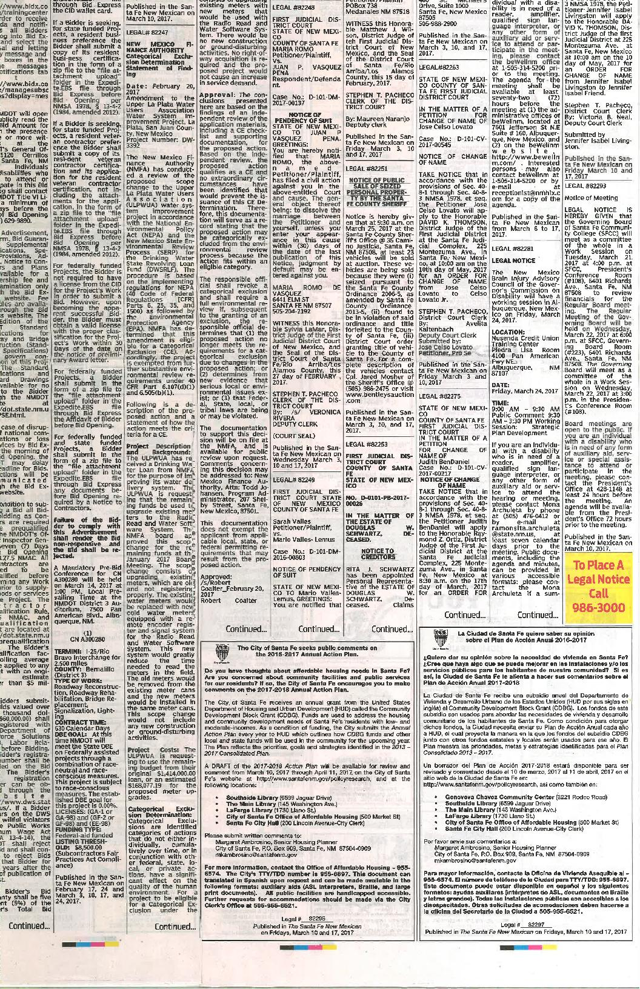
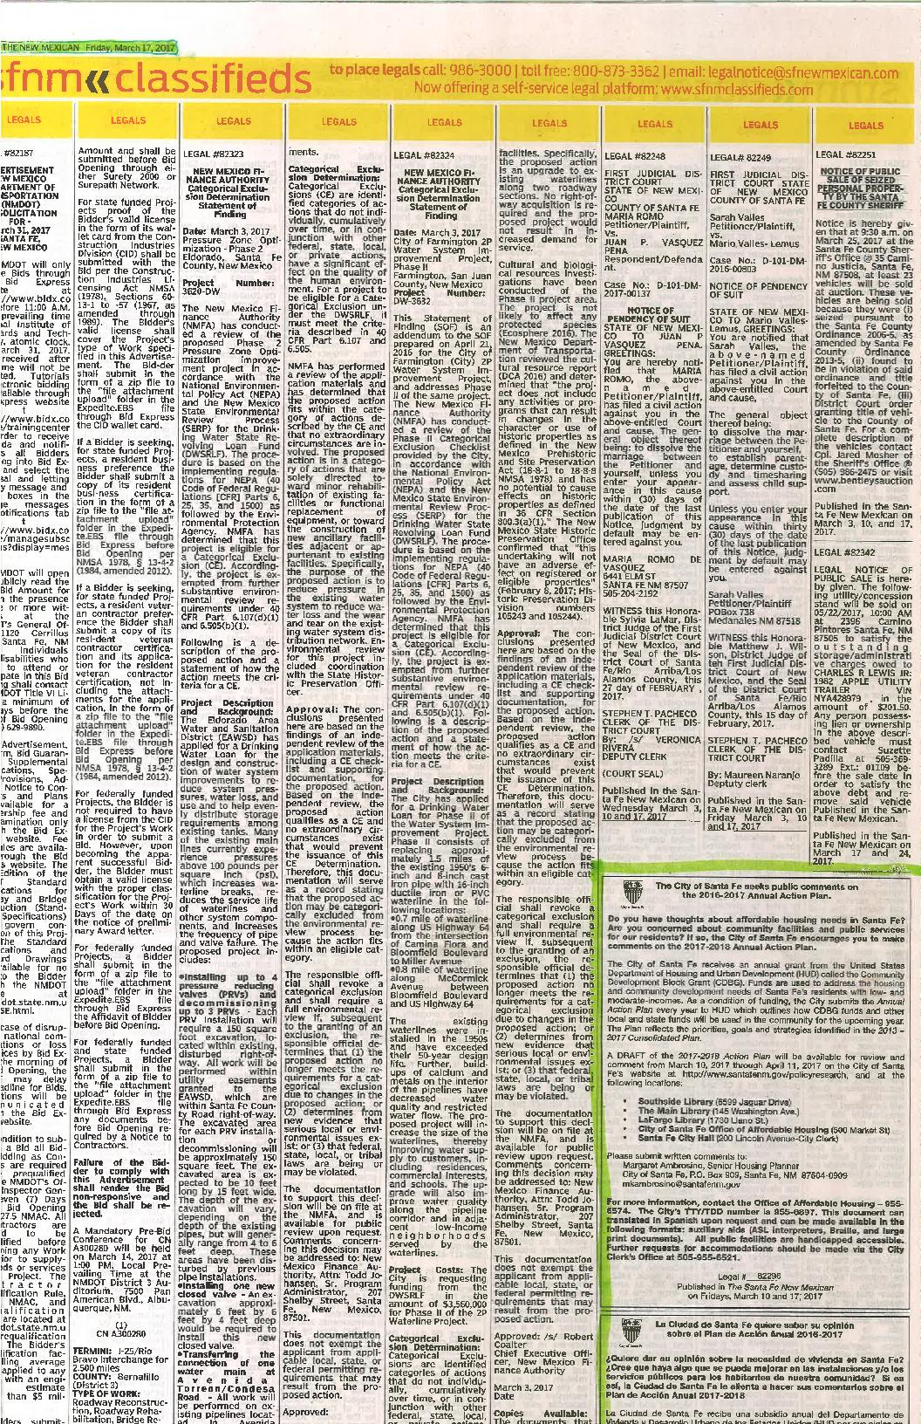
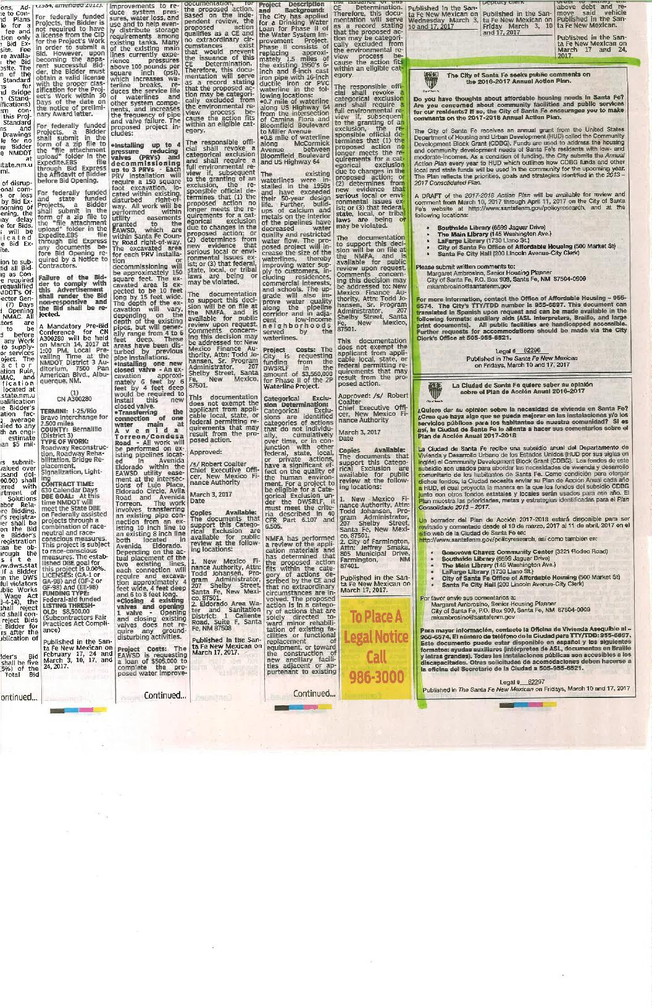
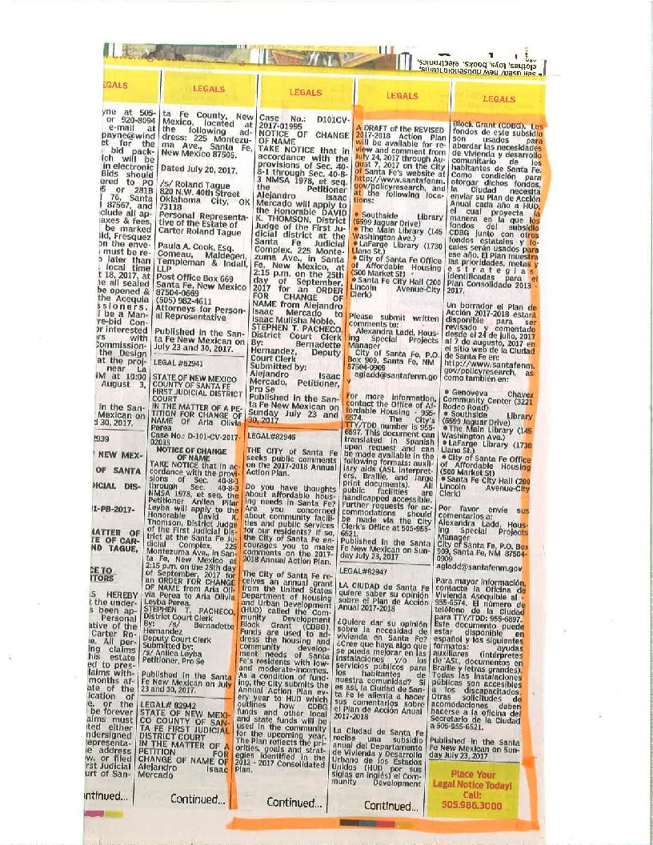

Grantee SF-424's and Certification(s)
