Procedures for Using ESS

- Obtain your user ID and password by signing into your kronos.
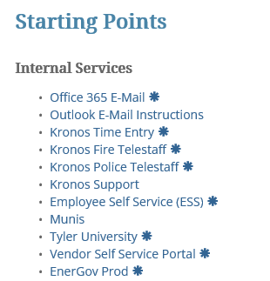
- Enter your username and password (If you have never signed into kronos through the computer get with your supervisor so they may get you access)
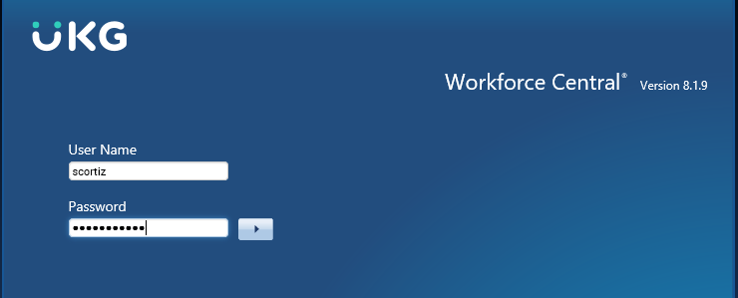

- To the right of the screen click on My Reports
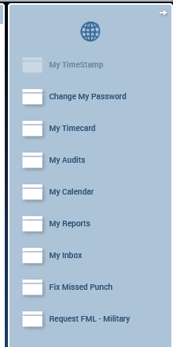
- Click on View Reports
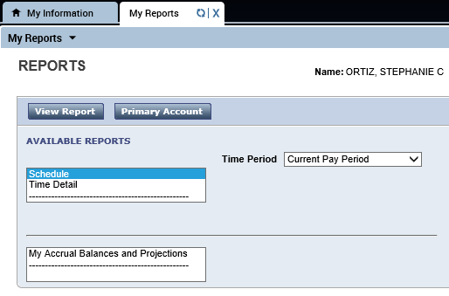
- Your user ID is your employee number usually six digits you will find this to the right of your name
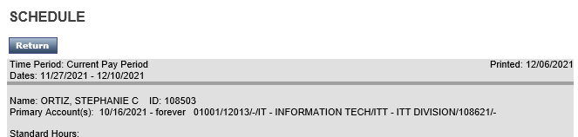
123456
- Once you have obtained your user ID in SharePoints click on Employee Self Service (ESS) link
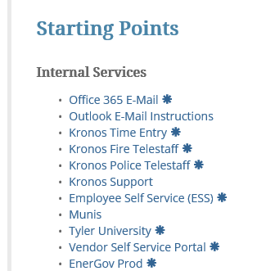
- Click Log In

- Enter your User ID (employee ID) and password (if this is the first time using this link your password will be the last 4 digits of your SSN or if you have applied for a job recently the password will be the same) and click log in
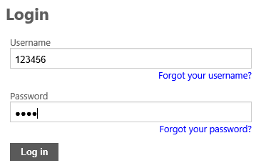

HOW TO LOCATE AND PRINT YOUR CHECK STUB
- Once you are logged into to ESS to the right of the screen click Pay/Tax Information
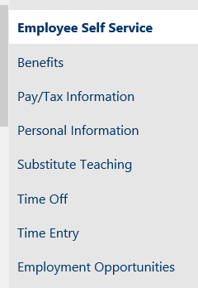
- You will see all check stubs for the year selected to retrieve a check stub click deatails
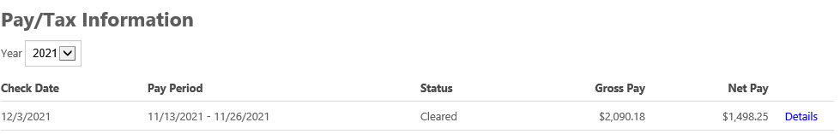
1,450 1.234
- This will bring you to a screen of Check Details click View Paycheck Image
- You will be able to view your check stub to print your check stub click on the printer to the top of the page
- Click Print
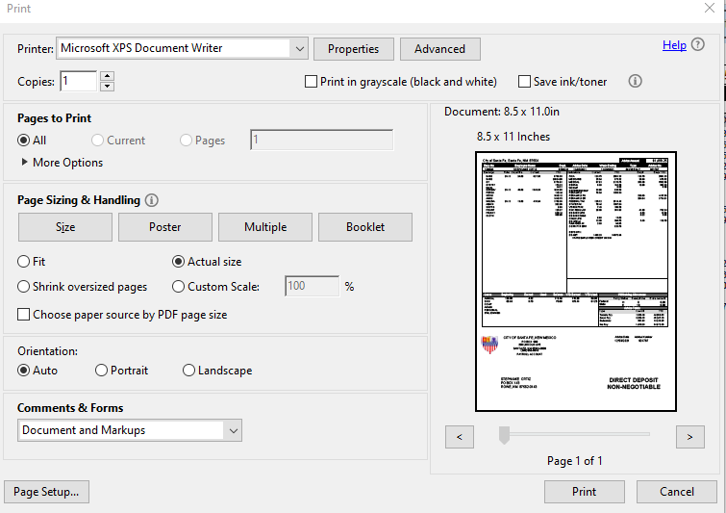

HOW TO VIEW/PRINT YOUR W-2
- In Pay/Tax Information click on W-2
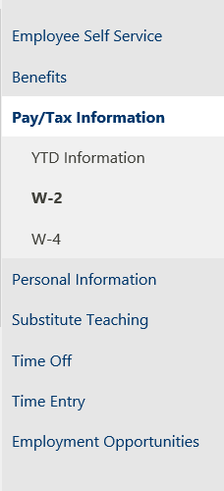
- Select year you want to view (reminder the system only has 2019 forward if you need past 2019 contact payroll) click View W-2 Image

- Click and View the document needed
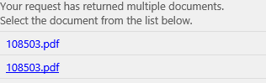
- To Print click the printer at the top of the screen
- Click Print
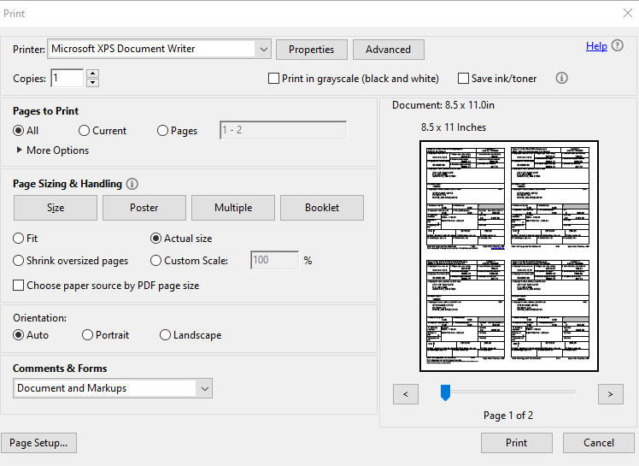

HOW TO VIEW/PRINT AND CHANGE A W-4

- Click on Pay/Tax Information
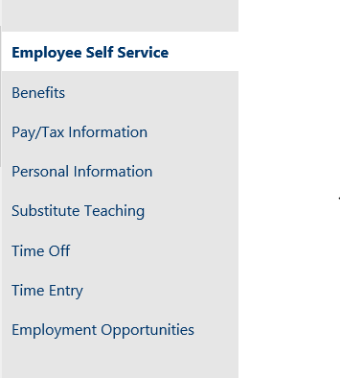
- Click on W-4
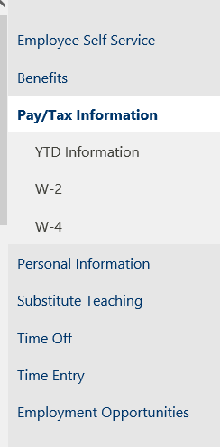

- At the bottom of the screen click edit
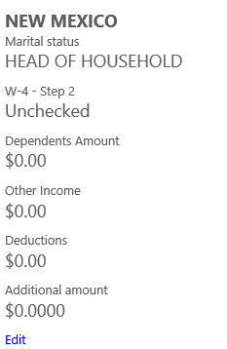
- Make changes as needed to Federal and type your name when completed
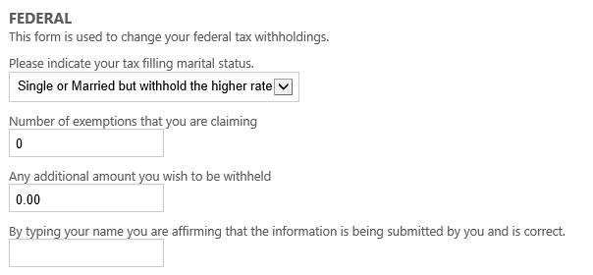
Kate Smith

- Make changes as needed to State and type your name when completed
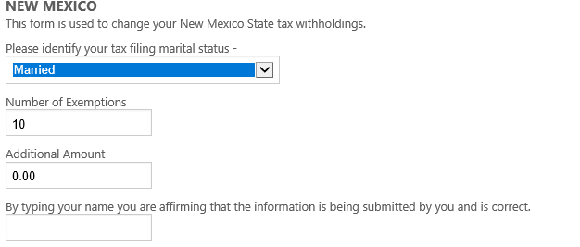
Kate Smith
- Click Submit NOTE: BY CLICKING SUBMIT YOU ARE REQUESTING PAYROLL TO CHANGE YOUR DEDUCTIONS PAYROLL MUST APPROVE THE CHANGES BEFORE YOU CAN VIEW CHANGES.
