ESS STEP BY STEP FOR ANDROID
- In the Play Store search Munis ESS Mobile
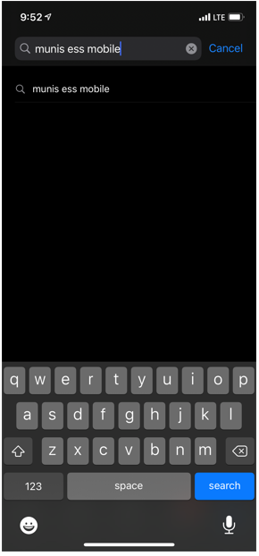
- Tap INSTALL to download
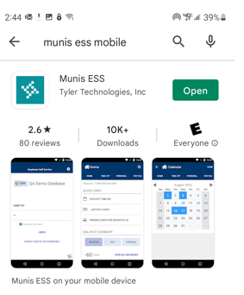
INSTALL

- Once it is downloaded tap open you will be prompted to scan a QR code
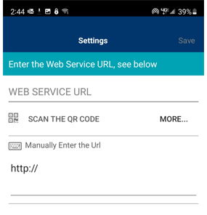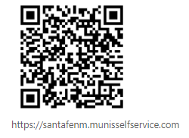
- Enter your username which will be your employee ID
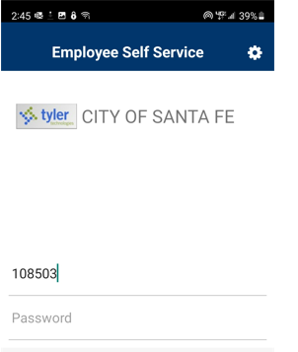
123456

- Obtain your user ID and password by signing into your kronos.
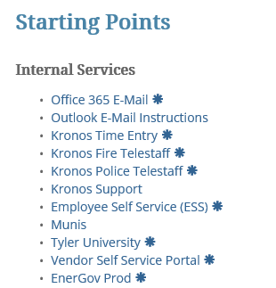
- Enter your username and password (If you have never signed into kronos through the computer get with your supervisor so they may get you access)
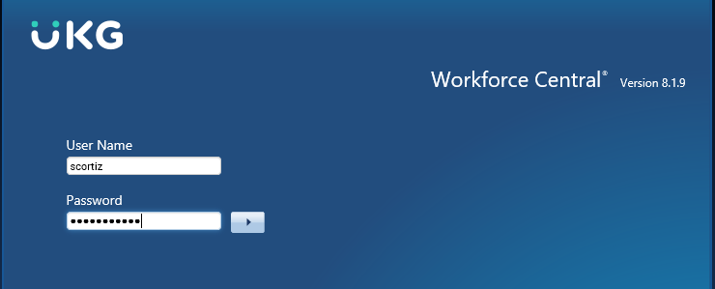

- To the right of the screen click on My Reports
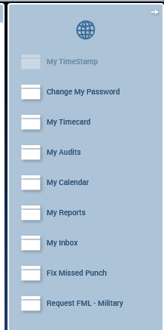

- Click on View Reports
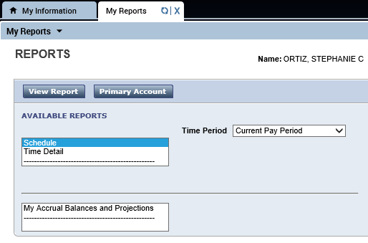
- Your user ID is your employee number usually six digits you will find this to the right of your name
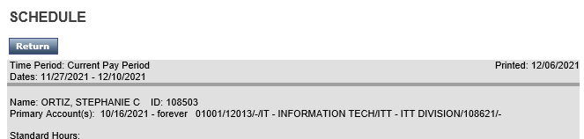
123456

- Enter your password (if this is the first time ever signing in your password will be the last for digits of you ssn)
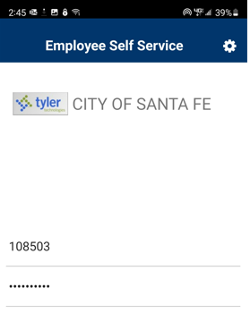
123456
- Tap the three lines down to the left of the screen and tap the Pay/Tax screen you will be able to navigate through your Personal Information, Pay/tax information (this will give you the opportunity to locate check stubs, W-2 information and W-4 information.)
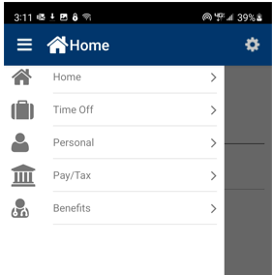

- You may also look into your benefits for example your medical, dental, and vision deductions.

