City of Santa Fe
2022 Inauguration Ceremony
for
Mayor Alan Webber
and
City Councilors
Signe I. Lindell, District 1
Carol Romero-Wirth, District 2
Lee Garcia, District 3
Amanda Chavez, District 4
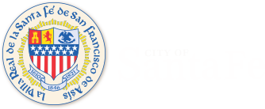
December 30, 2021, at 9:30 a.m.
Santa Fe Community Convention Center
201 W. Marcy Street
Pastries, coffee and tea will be served.

COVID-safe practices will be observed.
Masks required.
Proof of vaccination or proof of negative COVID test result within 72-hours of ceremony.

Members of the public are invited, space is limited. Please RSVP by December 27, 2021, to Erica Flores at 505-955-6324 or email ecflores@santafenm.gov

