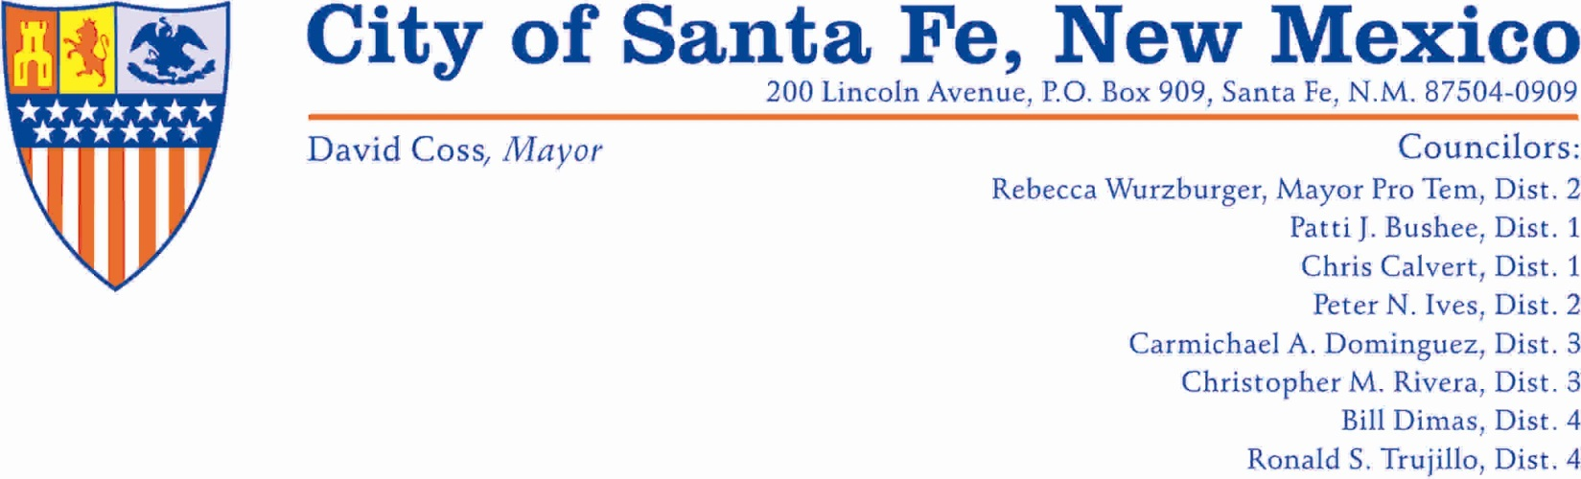
Santa Fe Municipal Watershed Access Authorization Request Form

The City of Santa Fe and the U.S. Forest Service control access to the upper Santa Fe River municipal watershed (Watershed) in order to comply with the 1932 federal closure order of the area and to ensure safe evacuation of the area in case of emergency. People entering Watershed either for regulation, environmental monitoring (Category 2) or educational work or on guided educational tours (Category 3) must fill out this form to request access the closed Watershed and either fax it to the City of Santa Fe Water Treatment Facility at 505-955-4379, or email it to Mike Gonzales at mlgonzales@santafenm.gov. Details on the amount of lead time, the response time, and other criteria are specified in the Procedures to Access the Santa Fe Municipal Watershed, which is available on the City of Santa Fe’s website at www.santafenm.gov. Employees and contractors whose work duties are considered essential and require frequent access to the watershed (Category 1) are exempt from this process.

Individual/Group Requesting Authorization
Name/Responsible Entity:____________________________ Organization:_____________________________________
Phone #’s (Day)_____________________(Evening) _____________________ (Fax) _____________________
E-Mail:__________________________________________

Specific Days and Times of Entry into Watershed:
From: Day/Time To: Day/Time
______________________________ ______________________________
______________________________ ______________________________

Description of Activity:
Purpose of Entry:___________________________________________________________ Category of Entry: 2 □ 3 □
Location of Activity in the Watershed:___________________________________________________________________
Number of People in Group:_________ Number of Vehicles_________________
If Category 3, City of SF or USFS Staff Guide: ______________________________________ Phone _______________

Release of Liability:
I fully understand and recognize that there are inherent risks associated with entry into the watershed and agree to hold the City of Santa Fe and the U.S. Forest Service harmless for any damage or injury to myself and /or my property. I understand that the City or the USFS reserve right to deny access at any time. I understand that Watershed access is authorized only for the dates, times, and locations noted above. I understand that I must have a picture identification and a copy of this authorization form with the group while in the Watershed and that security personnel may request to see either. I understand that smoking and all open flames are strictly prohibited in the Watershed. I understand that if I observe a fire in the Watershed, I will call 911 as soon as possible and leave the municipal watershed immediately.

Signature of Responsible Party:__________________________________________________________
Emergency Contact Name______________________________Phone ______________________ Picture ID □
**Please add the information and signatures from the other members in your group on the back..

ACTION TAKEN BY CITY OF SANTA FE or USFS:
Entry Authorized □ Entry Denied □
By City of SF or USFS Staff: _____________________________________________ Phone _______________
Release of Liability
I fully understand and recognize that there are inherent risks associated with entry into the watershed and agree to hold the City of Santa Fe and the U.S. Forest Service harmless for any damage or injury to myself and /or my property. I understand that the City or the USFS reserve right to deny access at any time. I understand that Watershed access is authorized only for the dates, times, and locations noted above. I understand that I must have a picture identification and a copy of this authorization form with the group while in the watershed and that security personnel may request to see either. I understand that smoking and all open flames are strictly prohibited in the watershed. I understand that if I observe a fire in the Watershed, I will call 911 as soon as possible and leave the municipal watershed immediately.

Name (print):________________________ Address: ____________________________________________________
Signature___________________________ ____________________________________________________
Emergency Contact Name______________________________Phone ______________________ Picture ID □

Name (print):________________________ Address: ____________________________________________________
Signature___________________________ ____________________________________________________
Emergency Contact Name______________________________Phone ______________________ Picture ID □

Name (print):________________________ Address: ____________________________________________________
Signature___________________________ ____________________________________________________
Emergency Contact Name______________________________Phone ______________________ Picture ID □

Name (print):________________________ Address: ____________________________________________________
Signature___________________________ ____________________________________________________
Emergency Contact Name______________________________Phone ______________________ Picture ID □

Name (print):________________________ Address: ____________________________________________________
Signature___________________________ ____________________________________________________
Emergency Contact Name______________________________Phone ______________________ Picture ID □

Name (print):________________________ Address: ____________________________________________________
Signature___________________________ ____________________________________________________
Emergency Contact Name______________________________Phone ______________________ Picture ID □

Name (print):________________________ Address: ____________________________________________________
Signature___________________________ ____________________________________________________
Emergency Contact Name______________________________Phone ______________________ Picture ID □

Name (print):________________________ Address: ____________________________________________________
Signature___________________________ ____________________________________________________
Emergency Contact Name______________________________Phone ______________________ Picture ID □

Name (print):________________________ Address: ____________________________________________________
Signature___________________________ ____________________________________________________
Emergency Contact Name______________________________Phone ______________________ Picture ID □

Note: For more participants, please fill out on additional forms.

