OTAB Marketing Report
May 2015
Reported June 25th, 2015

TOURISM Santa Fe Marketing Team
- Cynthia Delgado, Director of Marketing
- John Feins, Public Relations Manager
- Blake Jackson, Marketing Coordinator
- Frank Cordero, Social Media Coordinator
Advertising & Social Media
- Fuseideas
  - Steve Mason, Senior Vice President
  - CJ Kaplan, Chief Creative Officer
  - Geenamarie Shuttleworth, Account Executive
  - Michael Durwin, Social Media
Website & Email Newsletters
- Studio X
  - Kyle Langan, Webmaster
  - Trudy Gibson, Project Manager

Press/Media
- Lou Hammond & Associates
  - Terry Gallagher
  - Carlyn Topkin
  - Matt Sessions
Santa Fe Travel Planner
- Bella Publishing
  - Bruce Adams, Publisher
  - Bryan Cooper, Creative Director

HIGHLIGHTS

2015 MAY NEW ACCOLADES
USA Today 10Best selected Santa Fe Farmer’s Market as the 10th “Best Farmers Market Every Foodie Should Visit.” Read more here.
USA Today 10Best named three Santa Fe spas in the top “10 Best Hotel Spas.” Spa at La Posada de Santa Fe placed 4th, Spa at Loretto at the Inn & Spa at Loretto placed 5th and Spa at The Four Seasons Rancho Encantado placed 9th. Read more about Santa Fe's spas here.
Fodor’s Travel recognized the Santa Fe Opera as one of “Summer’s 10 Best Outdoor Theater Experiences.” Read the Fodor's Travel coverage here.

TOURISM Santa Fe Shares New Creative Concepts

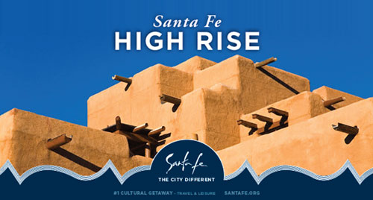
TOURISM Santa Fe has posted samples of advertising creative concepts that will support the media plan and execution schedule led by our advertising partner, Fuseideas.
About the Campaign
Virtually everything is different about Santa Fe. This campaign will show the rest of the U.S. why they should visit precisely because of that. This campaign features headlines that speak to things you could see or do every day—and marries them with stunning, iconic Santa Fe imagery. This juxtaposition further highlights Santa Fe as “The City Different”.
The treatment at the bottom of the ads is inspired by Native American pottery design motifs and the Santa Fe landscape—and provides a space that calls attention to the logo, tagline and call to action. The font stands sturdy with a subtle sense of roundness, not unlike an adobe building.
Please note that the photography shown in these concepts is meant to convey the concept only and are not final. In the coming weeks, we will hold a photo shoot to gather visual assets to support this campaign.
CLICK HERE to download a PDF of the new creative concepts from Fuseideas.

Santa Fe Great Race

The Great Race is the world’s premiere old car rally, a ＄150,000 prize event that this year will brought 120 of the world’s finest antique automobiles to the historic Downtown Santa Fe Plaza—the race’s first visit to “The City Different” since 1989.
Cars arrived in Santa Fe starting at 4:45 p.m. Tuesday, June 23 at one-minute intervals for two hours. Each stop on The Great Race is free to the public and spectators can visit with the participants and check out the cars for several hours. Kids will often climb right in the cars for a first-hand look.
Over the decades, The Great Race has stopped in hundreds of cities big and small, from tiny Austin, Nevada to New York City. “When The Great Race pulls into a city it becomes an instant festival,” race director Jeff Stumb said. “Last year we had three overnight stops with more than 10,000 spectators on our way to a total of 250,000 people experiencing The Great Race.”
Hopefully another quarter century won’t pass before The Great Race returns to Santa Fe.
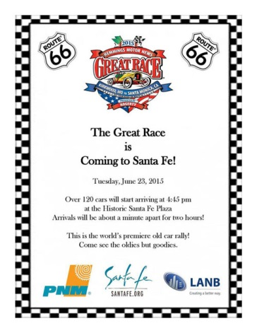
SUMMER OF COLOR
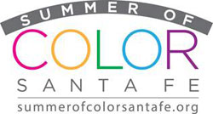
Six of Santa Fe’s leading cultural institutions located on Museum Hill have announced the Summer of Color celebration, with special exhibitions, events, programming, and lectures. The event has now evolved into a city-wide collaboration.
Gallery participants will create color-themed exhibitions and special art events; restaurants will feature colorful menus; and hotels, motels and bed and breakfasts will offer specialty vacation packages. Community response is growing and 75+ galleries and restaurants are participating in Santa Fe's colorful celebrationǃ

Community Meetings
TOURISM Santa Fe officials met with the following partners and organizations during the month of April to expand the Santa Fe brand:

Santa Fe CommUNITY Day
Hilton Santa Fe Historic Plaza
Four Seasons
Bishop’s Lodge
Ojo Caliente
Inn of Loretto
Anasazi Tweet Up
Buffalo Thunder Santa Fe Hilton
Museum of Indian Arts and Culture
Pojoaque Pueblo
Santa Fe International Folk Art Market
JLHMedia at Shiprock Gallery

WEBSITE

May 2015 Performance Metrics
Visits
- 90,304 Total Visits
- 70.90% New Visits
- 2.87 Pages per Session
- 3:19 Average Time on Site
- 259,554 Total Pageviews
Visitor Gender
- 61.4% Female
- 38.6% Male
Visitor Age
- 6.10% 18 - 24
- 17.55% 25 - 34
- 6.10% 18 - 24
- 17.55% 25 - 34
- 13.68% 35 - 44
- 16.56% 45 - 54
- 25.80% 55 - 64
- 20.32% 65+
Newsletters
- Santa Fe Happenings
  - Sent May 12, 2015
  - Number sent: 41,803
  - Number opened: 7,140
  - Open rate: 17.36%
- TOURISM Santa Fe Marketing Report
  - Sent May 13, 2015
  - Number sent: 1086
  - Number opened: 379
  - Open rate: 34.93%
- Stay Another Day in Santa Fe
  - Sent May 21, 2015
  - Number sent: 16,401
  - Number opened: 2,813
  - Open rate: 17.36%
- TOURISM Santa Fe Sales Report
  - Sent May 26, 2015
  - Number sent: 1095
  - Number opened: 396
  - Open rate: 36.16%
- Conde Nast Survey
  - Sent May 19, 2015
  - Number sent: 58,806
  - Number opened: 9,874
  - Open rate: 17.49%
SOCIAL MEDIA UPDATES

Facebook

May 2015 Performance Metrics
- Total Fans: 37,443
- Top Ranking Post, May: Organic News
  - Posted May 7 at 2:40pm
  - Likes: 850
  - Shares: 157
  - Comments: 51
  - Reach: 23,376
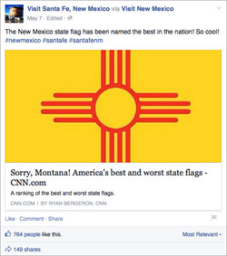

Twitter
May 2015 Performance Metrics
- Followers: 9,008
- Monthly Impressions: 229,900 (increase of 73,900 from April)
- Average Daily Impressions: 7,400/day
- Highest Organic Impressions: May 12 (58,858)
- Link Clicks: 1,100
- Retweets (earned): 500
- Favorites (earned): 789
- Replies: 93
Please make sure to add #SantaFe, #SantaFeNM or #CityDifferent to your own Tweets and retweet TOURISM Santa Fe's tweets to keep your followers engaged and informed.
Pinterest

Please make sure you are following our Pinterest page as we continue to add content to our boards.
May 2015 Performance Metrics
- Followers: 1,790
- Pins: 1,562
- Average Daily Impressions: 1,836
- Average Monthly Viewers: 21,929
- Repins: 3
Instagram

May 2015 Performance Metrics
- Followers: 2,351
Top Performing Post in May: New Mexico State Flag, May 7: 248 Likes
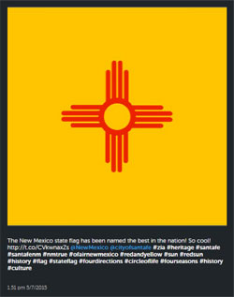

Blog
Every Tuesday we post a new blog entry, please share via Facebook and Twitter with your fans. Below are links to our last four entries for your sharing pleasure.
May 2015 Performance Metrics
Beef Up National Burger Month, posted May 1, 2015
- Likes: 256
- Shares: 53
- Comments: 55
- Pageviews: 83
Santa Fe Summer is Totally Technicolor, posted May 8, 2015
- Likes: 44
- Shares: 5
- Comments: 1
- Pageviews: 209
Painting the Plate Red in Santa Fe, posted May 15, 2015
- Likes: 704
- Shares: 116
- Comments: 61
- Pageviews: 56
Spring Into Summer in Santa Fe, posted May 20, 2015
- Likes: 47
- Shares: 11
- Comments: 1
- Pageviews: 87
Santa F(e)AQs, posted May 29, 2015
- Likes: 101
- Shares: 11
- Comments: 1
- Pageviews: 121
Total May pageviews: 2,107
TRIP ADVISOR
May 2015 Performance Metrics
- Pageviews: 18,029
- Link Clicks: 99
- Promo Clicks: 348
- Event Clicks: 32
- Photo Views: 2,479
- Video Views: 42
- Interaction Rate: 8%
MEDIA PLACEMENTS

DIGITAL
Mobile Banners
- Flight Dates: January 1 – June 30, 2015
- Markets: Denver, CO Springs, Tucson
- Impressions: 13,200,000
PRINT
Colorado Expressions
- Drop Dates: April/May & June/July, 2015
- Markets: CO
- Impressions: 780,000
Opera Ad
- Drop Date: July 15, 2015
- Markets: Santa Fe, New Mexico
MEETINGS
SmartMeetings (Meetings & Conventions Package)
- Drop Dates: January 1 - June 30, 2015
- Markets: TX, CO, AZ, Washington D.C., Chicago
- Impressions: 7,837,401
PUBLIC RELATIONS
April was one of the top two months ever for TOURISM Santa Fe earned media. May has surpassed April with a value of ＄3,067,271 and a total reach of 212,117,549. Last May the earned value was ＄701,055 with a reach of 35,162,949. This is an increase of over 337.5 percent in value and over 600 percent in reach. 29 press releases and written copy were distributed in May, a 480 percent increase from May 2014.
While we can’t plan for every month to be so successful, we can attribute these increases to a philosophy of “Say Yes To Press". How do you get good coverage in the news? Partner with TOURISM Santa Fe: When there’s a Hot Tip, we act on it. When there’s a media inquiry, we respond immediately and fully. When a writer visits, which we encourage and support, we’re sure to provide a robust and broad-based itinerary and spend time with them so they get to know Santa Fe—both the stories of the past and the equally exciting ones taking place this very day.
There’s a web component to PR, a social media aspect, but ultimately it boils down to what the words mean: “public” and “relations.” Say yes to press. Get to know them as people and treat them naturally like family. Relate to their needs as professionals and not just your own needs. Value is being realized by those who take the responsive and inclusive approach of just saying yes to press.
Santa Fe in the News | Recent Articles

NEWSPAPER (print/online)
The New York Times included Santa Fe in a round-up of “20 Family-Friendly Travel Ideas To Get You Going.” The coverage ran both online and in print. Read these family-friendly ideas here.
Syndicated coverage of the article also appearing in the following publications:
- The New York Times
- The Seattle Times
The New York Times included the Santa Fe Opera in a round-up of “50 Essential Festivals,” an annual round-up focusing on the best art performances. Coverage ran both online and in print. Read the New York Times article here.
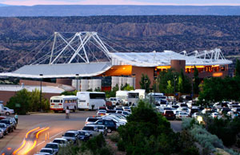
The Albuquerque Journal published a dedicated article on Santa Fe’s markets. Read the Albuquerque Journal article here.
The Albuquerque Journal included Santa Fe in a round-up of music festivals and concert series in New Mexico. Check out when music festivals and concerts will be happening here.
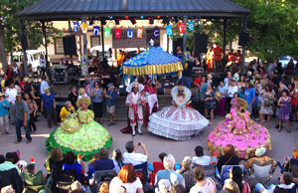
USAToday.com included the Santa Fe Animal Shelter & Humane Society in an article, “Voluntourism: Animal Shelters that need your help.” Read the USAToday.com article here.
The following news publications ran syndicated coverage of the article on USAToday.com:
- Alexandria Daily Town Talk
- Fort Myers News Press
- Ithaca Journal
- Lafayette Journal & Courier
- Muncie Star Press
- Rochester Democrat & Chronicle
- Wausau Daily Herald
- Cincinnati Enquirer
- Elmira Star Gazette
- Louisville Courier-Journal
- Indianapolis Star
As a result of TOURISM Santa Fe hosting Ray Rinaldi and ongoing outreach, The Denver Post included Santa Fe in a round-up of 2015 Summer Arts, highlighting the Santa Fe Opera. Read the Denver Post article here.
WEBSITES
As a result of Ski Santa Fe and TOURISM Santa Fe hosting Mike Terrell on the SKI Santa Fe press trip, SnoCountry published an article, “Trip Report: Santa Fe and New Mexico Are A World Apart From Everyday American Skiing.” Read the SnoCountry article here.
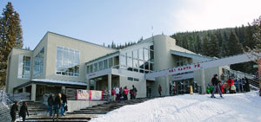
As a result of Ski Santa Fe and TOURISM Santa Fe hosting Eric Wagnon on the SKI Santa Fe press trip, Liftopia The Blog included Santa Fe in this article, “10 Things You Didn’t Know About Skiing in New Mexico.”
A syndicated version of the article by Eric Wagnon appeared on Huffington Post Travel. Read the Huffington Post article here.
Eric Wagnon also posted coverage on the Examiner, highlighting Ski Santa Fe in a round-up of “8 New Mexico Resorts.” Read the Examiner article here.
As a result of TOURISM Santa Fe hosting Lisa Keating in the destination, EncinoMom published a dedicated feature on Santa Fe. Read the Encino Mom article here. More coverage followed here and on YouTube here.
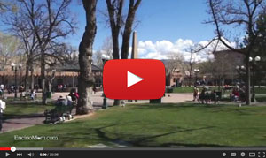
Additional coverage is expected on The Skate School, and EncinoMom is planning a return to Santa Fe soon to cover The Summer Of Color and other attractions.
As a result of TOURISM Santa Fe hosting Renee Blodgett in the destination, We Blog the World posted four pieces on Santa Fe in May:
- “5 Outa This World Santa Fe Restaurant Picks”
- “What Will You Find on the High Road to Taos?”
- Meet Four Seasons Rancho Encantado's Terra Restaurant
- “Must See & Do Guide to Santa Fe New Mexico”
As a result of TOURISM Santa Fe hosting Katie Chang in the destination, Ask Men included Santa Fe in this article titled, “Oxygen Skincare Treatments,” spotlighting the Inn and Spa at Loretto. Read the Ask Men article here.
Travel Pulse included Santa Fe in a round-up of “Five Great Cities For A Great Burger.” Read Travel Pulse here.
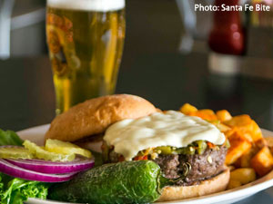
As a result of TOURISM Santa Fe hosting Hope Philbrick, Getaways for Grownups published two pieces featuring Santa Fe:
- The outlet included hotel coverage in Santa Fe in an article “Heritage Hotels & Resorts.” You can read it here.
- The outlet provided dedicated coverage on Santa Fe, spotlighting Hotel Chimayo de Santa Fe. You can read it here.
As a result of TOURISM Santa Fe hosting Christine Wei in the destination and ongoing outreach, Sherman’s Travel Blog included Santa Fe in this article, “Where to Go In July 2015.” Read the Sherman's Travel article here.
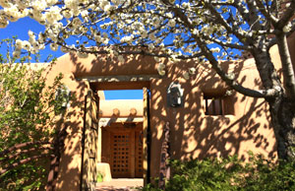
Cheap Tickets included Santa Fe in this round-up of “America’s Most Amazing Meals For ＄10 Or Less,” highlighting the Frito Pie Bowl at The Beestro as a result of media outreach. Read the Cheap Tickets article here.
Time Out New York included Santa Fe in this round-up of “Most Romantic Hotels in America,” highlighting Four Seasons Resort Rancho Encantado. Read the Time Out New York article here.
As a result of TOURISM Santa Fe hosting Katie Chang, Food Republic provided dedicated coverage on Santa Fe’s dining scene in this article, “6 Places to Eat Really Well in Santa Fe, New Mexico.” See which Santa Fe eateries made the list here.
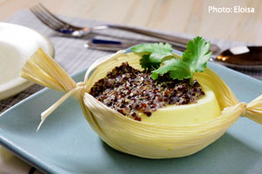
As a result of TOURISM Santa Fe hosting Larry Vaught in the destination, Vaught’s Views published the following two pieces on Santa Fe:
- Santa Fe’s Kakawa Chocolate House A Real Treat
- Bandelier National Monument Provides a Unique Opportunity
ABCNews.com provided dedicated coverage of Santa Fe in this article titled, “See This, Skip That: Santa Fe.” Read the ABC article HERE. The following outlets ran syndicated coverage of the article:
- News Reality
- World News
- Comunitee
- KXOT News Gazette
As a result of media outreach, EDGE Boston featured Santa Fe in this article, “Santa Fe Goes Gay This Summer.” Read the EDGE Boston article here.
MAGAZINES (print/online)
Due to Ski Santa Fe and TOURISM Santa Fe hosting Jennifer Colosimo on the SKI Santa Fe press trip, Points North Magazine included Santa Fe in an article titled, “New Mexico’s Oasis for Skier” in the January 2015 print and online edition. Read the Points North Magazine article here.
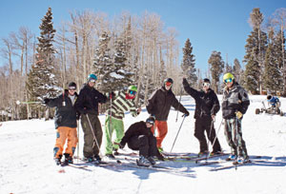
As a result of Ski Santa Fe and TOURISM Santa Fe hosting Debbie Martinez on the SKI Santa Fe press trip, The Florida Villager featured Santa Fe in an article in the February 2015 issue print and online edition. Read The Florida Villager article here.
As a result of TOURISM Santa Fe hosting Eric Peterson in the destination, Mountain Meetings included Santa Fe in a round-up of venues and outdoors spaces. Coverage ran in print and online. Read the Mountain Meetings here.
Southwest: The Magazine included Santa Fe as part of a feature, “Spirit of New Mexico.” Coverage ran in print and online. Read the Southwest article here.
Due to Jennifer Broome visiting the destination, Ten West Living published a six page feature on Santa Fe. Coverage ran in print and online. Read the Ten West Living article here.
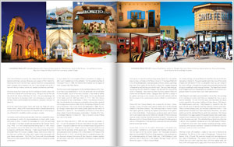

Visiting Press

Joanna Muenz of Latina.com visited Santa Fe May 7-10 for coverage on the city as a girlfriend getaway.
Kasey Hickey of Turntable Kitchen visited Santa Fe May 8-11 to produce coverage for her blog, spotlighting the food and cultural institutions in the destination.
Steve Bergsman visited Santa Fe from May 9-11 to produce coverage in East Valley Tribune and Creators Syndicate on the destination.
Larry Vaught visited Santa Fe from May 16-23 to produce coverage in The Advocate Messenger on the destination.
PBS documentarian Matt Maisano visited Santa Fe for an extended period in mid May to film Santa Fe and subjects for his upcoming Forrest Fenn documentary.
CBS Sunday Morning also visited in May to cover Forrest Fenn. TOURISM Santa Fe also promoted new stories in the destination.
Neil Wolkodoff visited Santa Fe from May 17-25 to research for future travel coverage in Colorado Avid Golfer, Examiner.com and Everett Potter.
Shannon Eileen visited Santa Fe May 27-31 to produce coverage for her blog, Happiness Is.
German sports and travel publication Eishockey News writer Tobias Welck visited Santa Fe from June 1-3.
Arizona Foothills Magazine visited Santa Fe from June 7-9 to research for a story on Las Campanas and on Santa Fe.
German Travel writer Dr. Christian Falsche visited Santa Fe from June 10-12 to produce coverage for German hotel and restaurant publication AHGZ and possibly other outlets.
Writer Dave Taylor of gofatherhood.com visited Santa Fe from June 11-14.

